Co-visits/Flip visits were designed as a model to support Clinica’s goals to improve nurse and provider ability to see minor acute patients together, improve same day access for patients and allow nurses to work in their scope. A day with co-visits/flips can be a beautiful thing when properly supported and executed. They can also be disastrous to the nurse’s workload if piled on top of all of the typical work with no additional consideration!

Co-visits/Flips can require more time from the nurse compared to the old manner of double books. The additional activities required for the Flip Visit are supported by the specific structure of Pods 2.0 which allows the nurse to spend extra time in the Flip visit without having other pod responsibilities build up in her absence:

- Triage off the pod
- Extra RN support (at least 2.5 nurses/pod)
- Additional pod MA
- Provider & Nurse schedule blocking to accommodate Flips
Even without the full support of the Pods 2.0 structure, we want to encourage the continued development of co-visits/flips while acknowledging the limitations posed by our current structure. We want to absolutely promote the skill of doing these visits AND promote the appropriate climate so nurses/providers all feel successful in doing these! Our suggestion is to utilize Co-visits/Flip Visits as much as possible as a strategy when the following circumstances are present on a given clinical day:

- Nurse FTE is 1.5 or more per pod
- Provider FTE allows enough access for consultation
- Co-visit/Flip patient meets criteria for chief complaint (not overly complicated)
- Nurse & provider agree this is a good strategy to address patient’s needs
- Nurse evaluates existing tasks, nurse visits, and other duties to ensure she has adequate time to complete all tasks. Communication between nurses essential to support this.
- Provider support ensures that nurses can be guided in successfully documenting/scribing.
Nurses/providers – please don’t stop doing these whenever you’re able to make them happen. And be sure to also set yourselves up for success by considering having the necessary support in place.

Co-visit/Flip Visit Expectations, Work-flow and Documentation Requirements:
Expectations
- Nurses: you are responsible for Subjective, Objective (see Flow below) and scribing for provider during provider portion of visit.
- Providers: you are responsible for Assessment and Plan, including medical decision making (MDM) and coding (see Flow below).You are required to make the necessary changes to the HPI and perform a physical examination on the patient.

Work-flow
- Nurse or MA rooms patient.
- Nurse makes sure the visit type is a Nurse Visit:
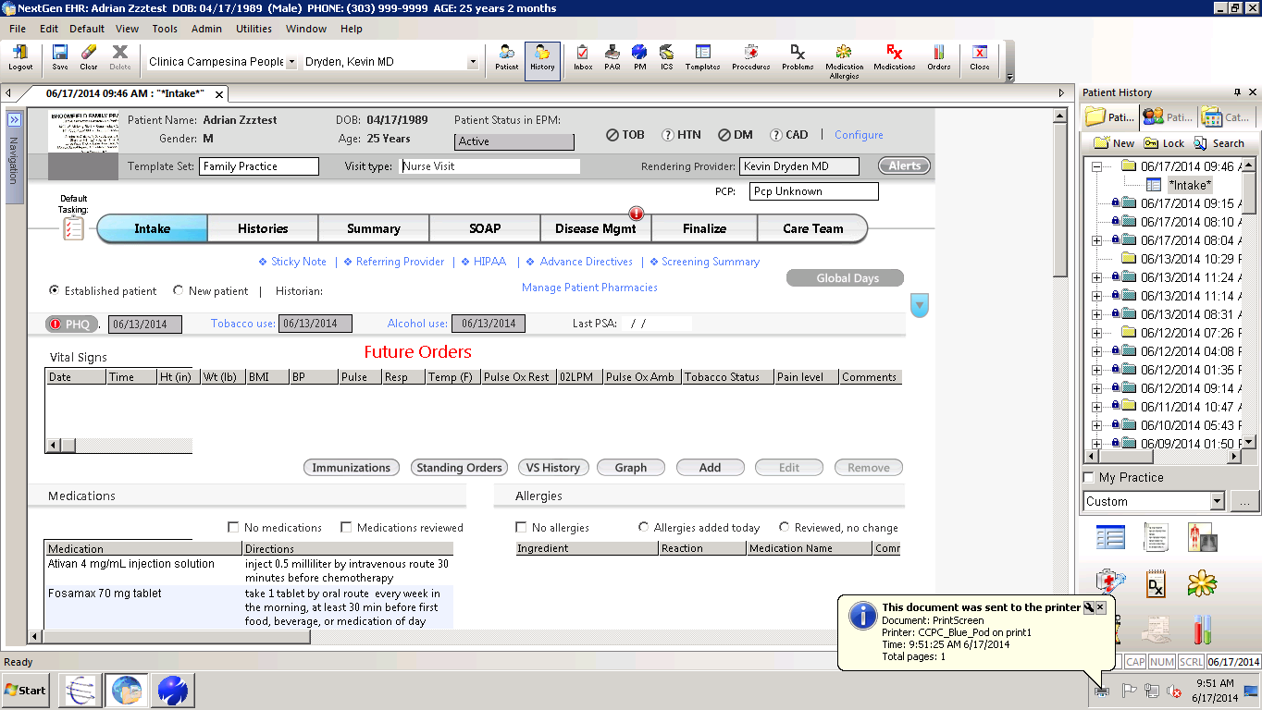

- Nurse documents reason of visit, HPI, ROS.
- Nurse performs in-office tests as needed for the visit.
- Nurse does a limited physical exam required to assess HPI and documents. No documentation of physical exam is done.
  - Nurse concatenates Chart note by clicking on the “Generate Document” button below the ROS on the Intake form (see below). Your name and credentials should be concatenated under your note now.

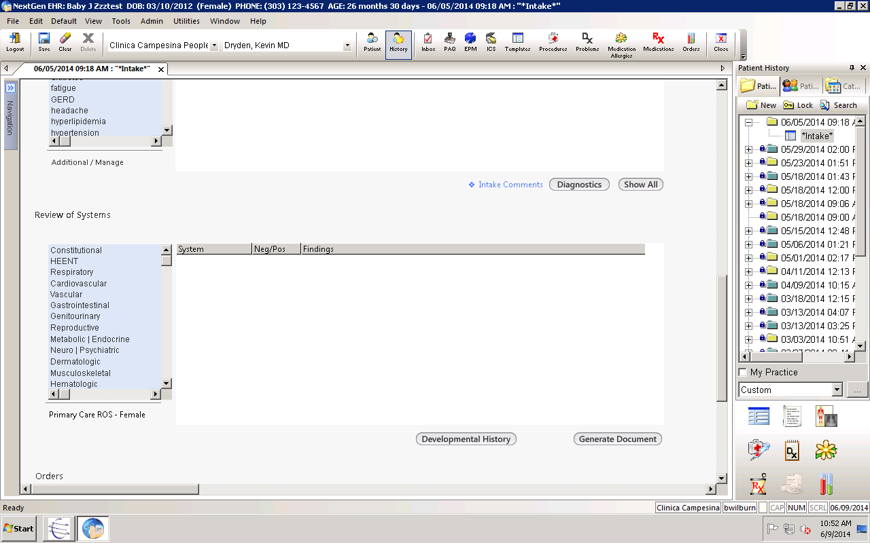
- Nurse then changes visit type to Office Visit:
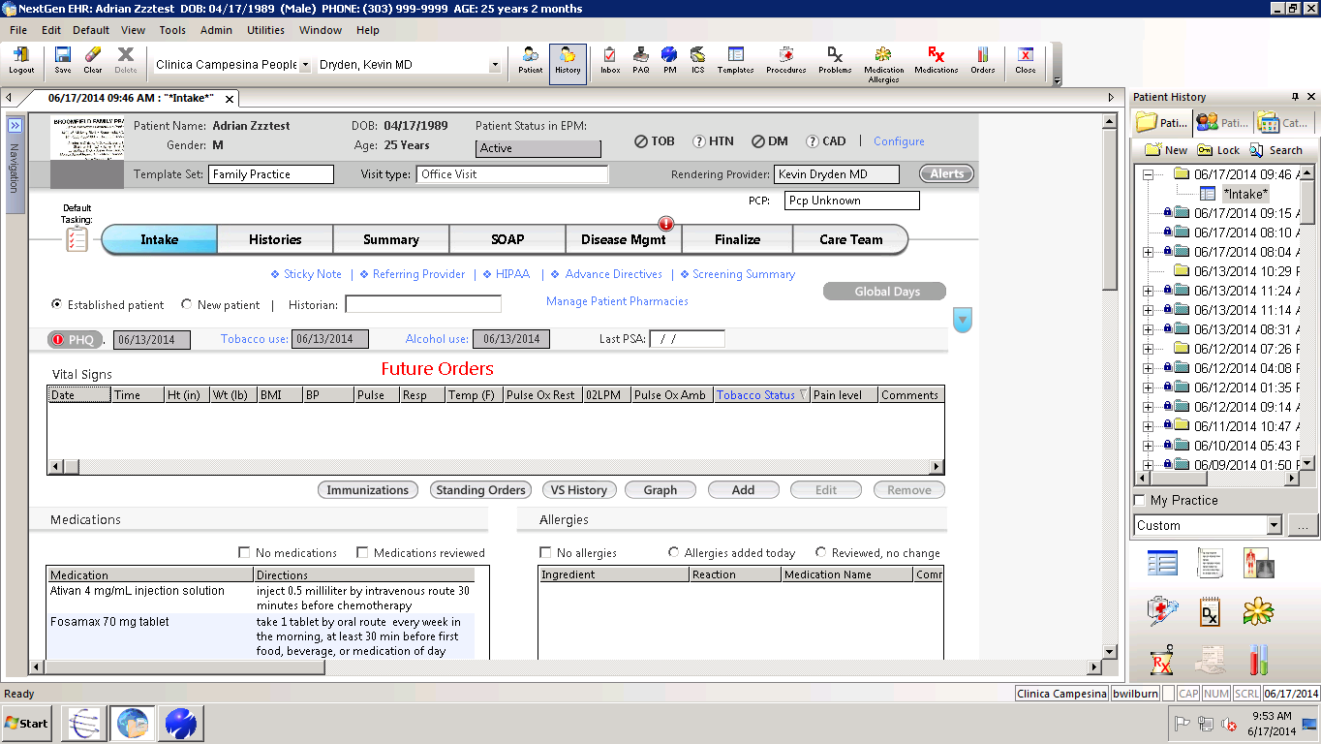

- Nurse presents case to the provider, in the presence of patient. The provider can obtain more history if needed and patient can add any other pertinent information they may not have discussed with nurse.
- Nurse and provider stay in the room together so nurse can document and scribe for provider.
- Provider does physical exam and advises nurse where and what to document for the physical exam.
  - If necessary, provider shows nurse where and how to document physical findings in NextGen. This can also happen outside the exam room after the visit is complete.
- Provider discusses case with nurse in the presence of the patient and decides on assessment (diagnosis) and plan.
- Provider orders (or verbally orders, orders by protocol) medications if needed while nurse scribes the diagnosis and the patient plan, and orders the medication.
- Nurse stays the room with patient and reviews assessment, plan of care, education including warning signs and follow up, and gives patient plan.

Nurse Visit Completion & Billing Documentation
- Once visit is complete, in the Finalize template, scroll down to the scribe documentation section and click on the scribe checkbox as shown below.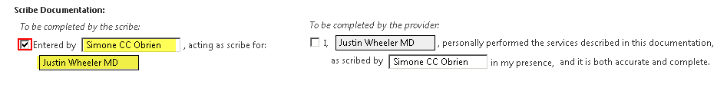
- Once this is done, make sure you click on the diamond in the Navigation Bar and update appointment status to “chart needs sign off”
- In EHR, right click on the date of service (usually on the right hand side under the history bar). Click on properties. Change Rendering to the provider the patient is seeing. Under Referring, add your name! If your name is in first consulting, clear it.
- Cut appointment from nurse schedule and move it to provider’s schedule.

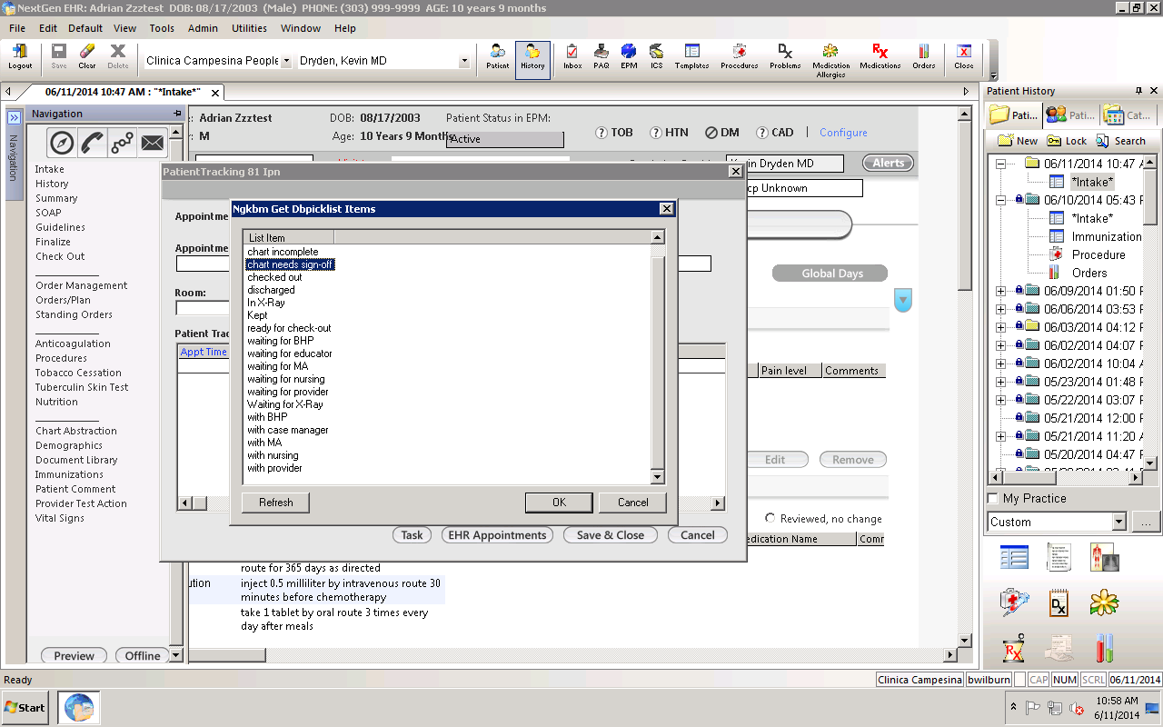

Provider’s Documentation for Billing:
- Provider is responsible for chart review, including all documentation, and coding, submitting to superbill.
- Document the Assessment and Plan (in conjunction with the nurse)
Once visit is complete, in the Finalize template, scroll down to the scribe documentation section and click on the scribe checkbox as shown below. 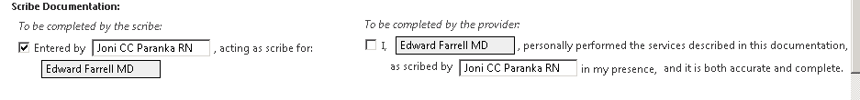
- Code the visit and submit.

