NURSE PROTOCOLS

2. NURSE TREATMENT GUIDELINES FOR POSITIVE LAB RESULTS

2.1 Urine Culture

2.2 Chlamydia

2.3 Gonorrhea

2.4 Strep A Throat Culture

2.5 H Pylori

2.6 Anticoalgulation

2.7 Rh Neg & Rhogam

2.8 Glucose Tolerance Tests

3. NURSE-ONLY VISITS/NURSE MANAGEMENT OF PATIENTS

3.1 Conjunctivitis

3.2 Otitis Media

3.4 Head Lice

3.5 Thrush in Children

3.6 UTI

3.7 PPD reading (positive)

3.8 Gulcola Contingency Plan

3.9 Antipyretics (for Nurse)

3.10 Non-Stress Test

3.11 Rapid Strep

3.12 Pertussis Treatment

Urine Culture treatment for female patients >12 years of Age

Definition of positive urine culture: single pathogen in excess of 100,000 organisms/ml of urine for voided specimen or any amount of a single pathogen on a catheterized specimen. For positive results treat per treatment protocols below.

Other results:

* 10,000 – 100,000 organisms/ml: consult with PCP for possible treatment or re-culture (depends on symptoms & dipstick results).
* < 10,000 organisms/ml: do not treat (unless GBS – see below).
* Samples with <100,000 organisms/ml of Lactobacillus are considered contamination with vaginal flora and are a negative result.
* Any level of GBS in pregnant patients – see below.

**Assessment**

* Allergies
* Fever (>100.4F) and chills, nausea, vomiting, flank pain, CVA tenderness or worsening symptoms since seeing provider. (Consult provider if patient has new onset of these symptoms since visit.)
* Pregnancy, LMP, contraceptive management

# **Treatment**

* Consult provider if patient is allergic to antibiotics.
* Compare list of sensitivities to the following medications/patient’s county and pick accordingly:
  + **ADAMS AND BOULDER COUNTY:**
    - **Non pregnant patients:**
      * NITROFURANTOIN monohyd/m-cryst (dual release, extended release, Macrobid)100mg TAB 1 BIDX5D #10 (about $16 @ Clinica)

**OR**

* + - * NITROFURANTOIN macrocrystal (regular release, Macrodantin) 100mg TAB 1 QIDx5D #20 ($12 @) Walmart)

**OR**

* CIPROFLOXACIN (Cipro) 250mg TAB 1 BIDX3D #6
  + - Per antibiogram data, these are all acceptable first line treatments for E. Coli.
    - **Pregnant patients:**
    - **Notify provider if pt has had >1 positive urine culture during this pregnancy** *If bacteria is GBS, note in prenatal* *Problem List & Labs. Task provider to notify positive GBS and to determine if treatment necessary. See below for documentation.* 
      * NITROFURANTOIN monohyd/m-cryst (dual release, extended release, Macrobid)100mg TAB 1 BIDX5D #10 (about $16 @ Clinica)

(Not during 36wks gestation to 30 days postpartum)*see below

**OR**

* + - * NITROFURANTOIN macrocrystal (regular release, Macrodantin) 100mg TAB 1 QIDx5D #20 (about $12 @) Walmart)

(Not during 36wks gestation to 30 days postpartum)*see below

* + - * Per BCH antibiogram, first-line treatment for **E.coli only.**

**OR**

* + - * AMOXICILLIN (Amoxil) 500mg TAB 1 BIDX5D #10

**OR**

* + - * CEPHALEXIN (Keflex) 500mg TAB 1 BIDX5D #10
  + **For dysuria**
    - * *PHENAZOPYRIDINE (Pyridium) 100mg TAB 1 TIDX2D #6

(also available OTC as “Azo”).

*= if patient would like to get this OTC med through the Clinica pharmacy,

make sure that you order the med in NextGen med module

# **Education**

* TOC for pregnant women 2 weeks post completion of treatment.
* Discuss how to take meds; emphasize finish all abx, even after symptoms clear. Use condoms if on BCPs.
* Prompt treatment is important to prevent pyelonephritis and permanent kidney damage.
* Prevention:
  + Urinate frequently, especially before and after intercourse. Completely empty bladder each time.
  + For female patients, encourage good perineal hygiene; wiping front to back.
  + Increase fluid intake. At least 2-3L of water daily.

*Macrobid inibits the G6PD enzyme in the baby, one of the things we test for in the newborn screen. Macrobid should not be given from 36wks gestation to 30 days postpartum.

*Call back for appointment with provider if:*

* **Not improving on antibiotics**
* **Signs and symptoms of pyelonephritis including, flank pain, fever, chills, vomiting, malaise.**
* **If patient has had multiple infections in the last year**

Document all of Above in Medical Record

and send “FYI” task to Provider who originally ordered lab.

**NextGen Documentation for GBS in Urine**

1. **Enter in OB Problem List:**

From the Medical Summary tab…

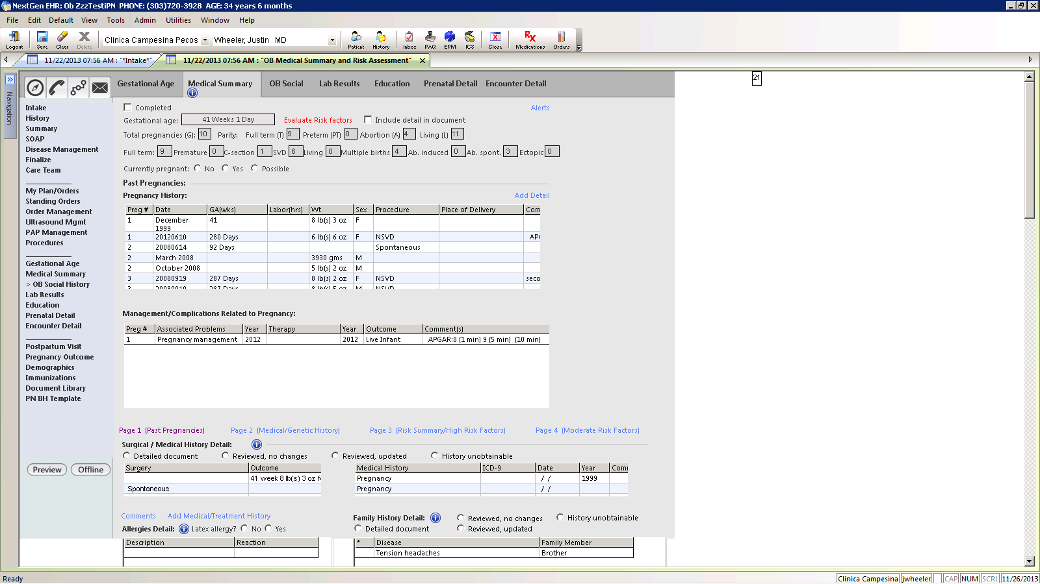

Scroll to Moderate Risk and select “GBS”. Enter information in the Detail box about the positive source, etc. Select “OK”.

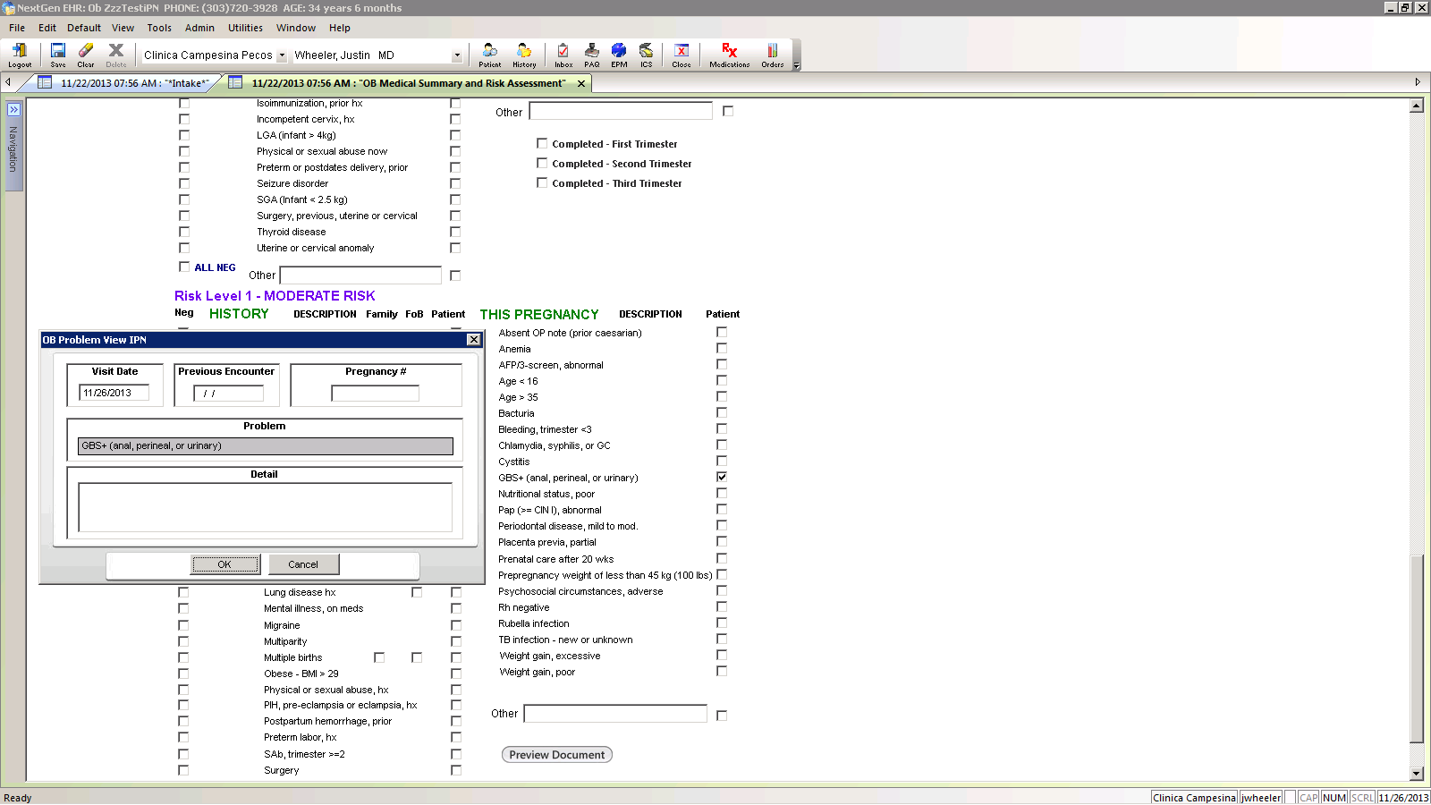

An entry will automatically be made in the Problem grid on Prenatal Detail.

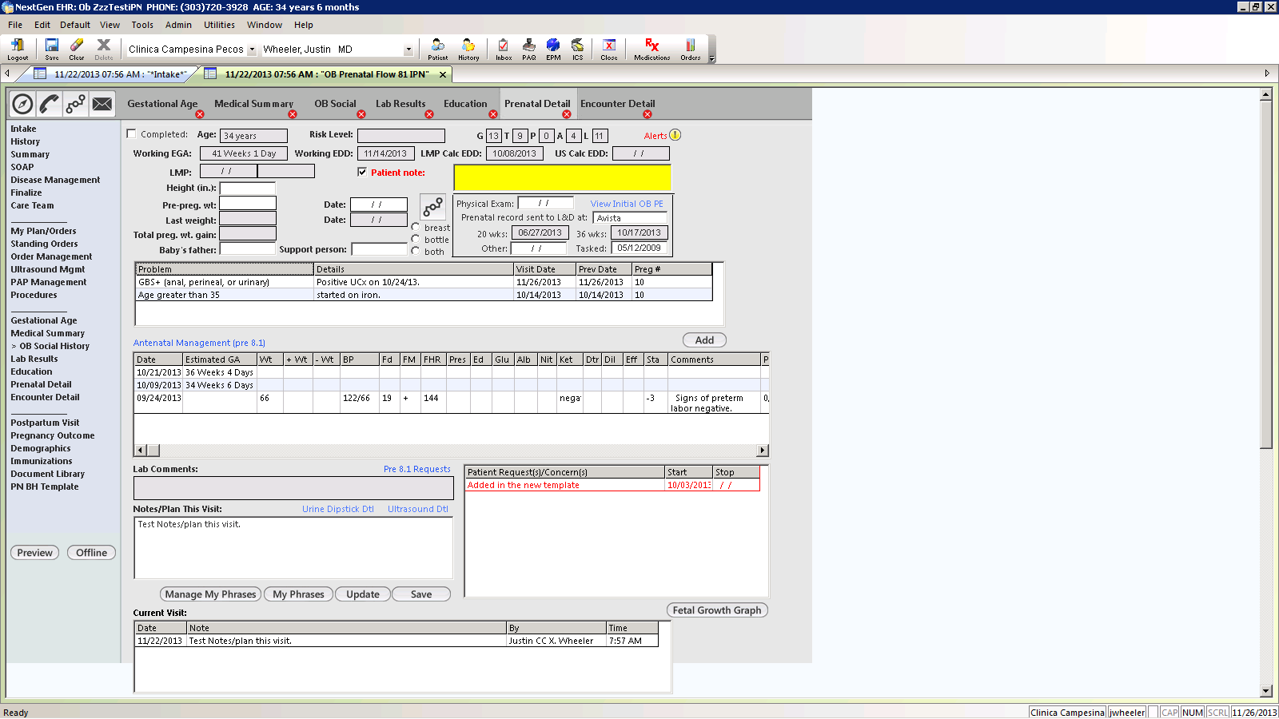

1. **Enter in Lab Results:**
   1. **From OB Pre-Natal Detail Template, click on Lab Results Tab**

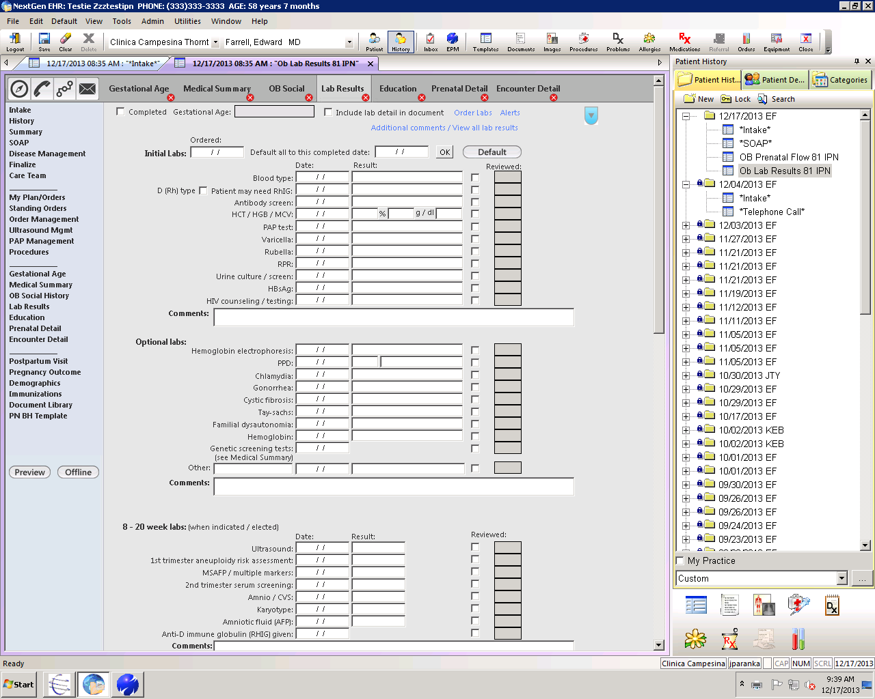

* 1. Scroll down to 32-36 week lab results & enter there (ok to enter even if lab done before 32 weeks; it’s very important to document the positive results!)

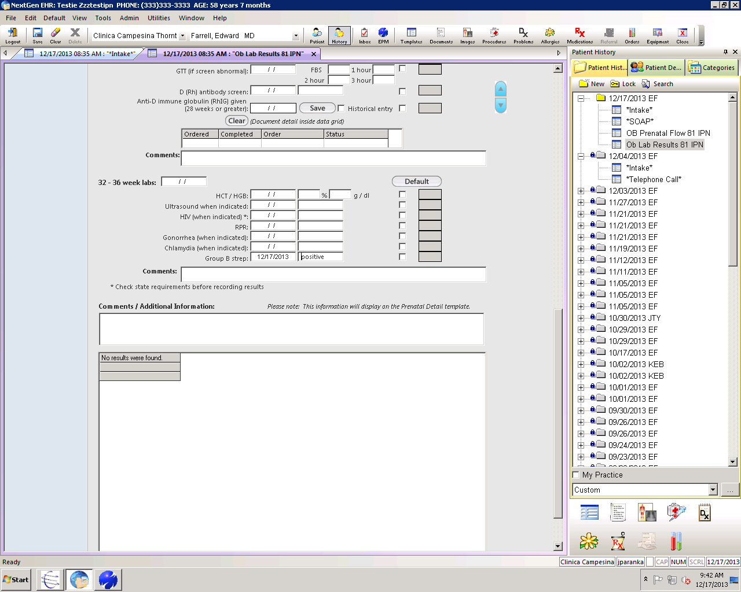

**Antibiogram Review:**

8/19/14: Antiobiogram data reviewed & no changes made to recommended antibiotic treatment

2.2 Chlamydia

Assessment

* Document Allergies, especially to antibiotics
* *Presence of fever, chills or severe abdominal pain since last visit.*
* History of sexually transmitted infection (STI), exposure to partner(s) with known STI, # of current partners and # of partners in prior 12 mos
* Menstrual pattern for women, including LMP and birth control method

Treatment

* **First Line Agents:**
  + - AZITHROMYCIN (Zithromax) 1G TAB 1 PO ONCE **or**
    - DOXYCYCLINE (Vibromycin) 100mg TAB 1 BIDX7D #14 **or**
* **Second Line Agents:**
  + - OFLOXACIN (Floxin) 300mg TAB 1 BID X 7 D #14 **or**
    - LEVOFLAXIN (Levaquin) 500 mg TAB 1 QD X 7 D #7

*Both of these agents are contraindicated in pregnancy and in patients < 18 years old

* **For Chlamydia and Gonorrhea co-infection**
  + - CEFTRIAXONE (Rocephin) 250mg IM, single dose. **Only if provider is in the clinic**

PLUS

* + - AZITHROMYCIN (Zithromax) 1G TAB 1 PO STAT

**OR**

* + - DOXYCYCLINE (Vibromycin) 100mg TAB 1 BIDX7D #14
* **\*\*\*Pregnant Patients with Chlamydia*****:**
  + - AZITHROMYCIN 1 G TAB PO ONCE **or**
    - AMOXICILLIN 500 MG CAP 1 PO TID × 7 DAYS #21 **or**
    - ERYTHROMYCIN BASE (Erythrocin) 500mg TAB 1 QIDX7D #28

*Erythromycin is associated with a high degree of GI complaints, most specifically nausea. Therefore the following lower dose 14 day regimens may be helpful in women who cannot tolerate high doses of this medication:

* + - ERYTHOMYCIN BASE 250mg TAB 1 QID X 14 DAYS #56
    - ERYTHOMYCIN ETHYLSUCCINATE 400mg TAB QID X 14 DAYS #56
  + If pregnant pt co-infected with Gonorrhea, she will also need Cefriaxone 250 mg IM single dose **only if provider in the clinic**

**Treatment of non-patient partners is no longer possible at Clinica due to issues of limited supply and malpractice insurance. If the partner is not a patient, please encourage the patient to have his/her partner become a patient here or to seek care immediately from the public health department or his/her PCP, especially because of the high re-infection rate (see below). If the partner IS already a Clinica patient, then by all means treat the partner as well. If this is the case, please be sure to open the partner’s chart and document both occurrence of infection and treatment in the telephone template.**

**Follow-Up Treatment**

* *Always bring a pregnant patient back 3 weeks after treatment for test of cure*. Pregnant patients should also be re-tested in 3 months if still pregnant.
* Patients with STIs (and those with Chlamydia in particular) are at increased risk of acquiring HIV, HPV and Hepatitis. Offer provider visit for STI consult and testing.

o Recommend Hepatitis B testing and vaccination to anyone whose vaccine series is not complete.

o Recommend testing for HIV and RPR now with repeat at 2 and 6 months, via MA, nurse, or provider visit according to patient preference and current access for the various visit types

* Chlamydia is associated with high rates of re-infection, often from the current or established partner. Recommend the patient to be re-tested in 3-6 months regardless of status of partner treatment.

**Patient Education**

* NO INTERCOURSE during treatment and for 1 week post treatment.
* Partner may not have symptoms but needs treatment anyway.
* Condoms help reduce the spread of Chlamydia and other sexually transmitted infections
* PID and infertility resulting from PID is more common in women who have had Chlamydia.
* Complications with pregnancy include low birth weight and premature rupture of membranes
* Review birth control methods.
* Discourage the use of douches and internal vaginal washes which destroy normal vaginal flora and make infections with cervical and vaginal pathogens more possible.

*Call back for appointment with provider if:*

* Symptoms of pelvic inflammatory disease (PID): Lower abdominal and pelvic pain, vaginal discharge, abnormal uterine bleeding, dysuria, dyspareunia (pain with intercourse), fevers and chills, malaise, vomiting
* Patient desires STI consultation

SEND COPY OF MASTER IM TO PCP FOR NOTIFICATION

General Information/Interesting Facts

* Chlamydia trachomatis (CT) is the most common pathogen of sexually transmitted genital infections. It is often asymptomatic.
* Chlamydia IS reportable in the state of Colorado
* If Chlamydia goes untreated in pregnancy**,** 20-50% of newborns may develop conjunctivitis and 10-20% may develop pneumonia
* Approximately 10-30% of women with Chlamydia will develop PID if untreated. Although gonorrheal infection is often more acutely symptomatic, PID with Chlamydia is more often associated with infertility.
* It has been estimated that approximately three million new cases occur annually in the United States. Over two thirds of these cases are not reported. C. trachomatis is an easily treatable infection. However, the prevalence of untreated infection is high, in part due to the asymptomatic nature of many infections. It is for this reason that clinical guidelines recommend routine screening of sexually active women under the age of 25 as well as ALL pregnant women.
* Primary prevention starts with education, and is the same for Chlamydial disease as for other STDs. The Centers for Disease Control and Prevention (CDC) stresses behavioral changes to reduce the risk of acquiring and transmitting STIs. This includes delaying the age of first sexual intercourse, reducing the number of sexual partners, and using barrier contraceptives. Another aspect involves screening asymptomatic individuals as well as testing those who are experiencing symptoms in order to identify and treat sexual partners.
* Chlamydia has a high male to female transmission rate of 65% (in male partners with urethritis).
* Pregnancy may predispose women to infection with C. trachomatis due to the physiologic immunosuppression of pregnancy and/or cervical ectopy.
* Cure rates tend to be lower in pregnant women, which is why a test of cure is required at 3 weeks post-treatment.
* Risk Factors:
* Adolescents and young adults
* Multiple sex partners or a partner with other partners during the last three months or a recent new sex partner
* Inconsistent use of barrier contraceptives
* Clinical evidence of mucopurulent cervicitis
* Cervical ectopy
* Unmarried status
* History of prior sexually transmitted disease
* Lower socioeconomic class or education not beyond high school

References: “Treatment of Chlamydia Trachomatis Infection;” “Genital Chlamydia Trachomatis Infections in Women” Uptodate, 2011

2.3 Gonorrhea (GC) Test

**Assessment**

* Document Allergies, especially to antibiotics
* *Any change in symptoms (fever, chills or severe abdominal pain) since seeing provider.*
* History of and/or exposure to STIs, # of partners in last year
* Menstrual pattern for women, including LMP and birth control method

**Treatment**

* **Non-pregnant patients:**
  + CEFTRIAXONE (Rocephin) 250mg IM, single dose. **Only if provider is in the clinic**

**PLUS**

* + AZITHROMYCIN (Zithromax) 1G TAB 1 PO STAT **OR**
  + DOXYCYCLINE (Vibromycin) 100mg TAB 1 BIDX7D #14

**As per the CDC and the state health department, treatment of gonorrhea should always include the dual therapy above, both as an attempt to combat early patterns of resistance to cephalosporins in the treatment of GC, as well as to presumptively treat a possible co-infection with Chlamydia, rates of which can be as high as 46%.

* **Pregnant patients**:
  + CEFTRIAXONE (Rocephin) 250mg IM, single dose. **Only if provider is in the clinic**

**PLUS**

* + AZITHROMYCIN 1 G TAB PO ONCE **or**
  + AMOXICILLIN 500 MG CAP 1 PO TID × 7 DAYS #21 **or**
  + ERYTHROMYCIN BASE (Erythrocin) 500mg TAB 1 QIDX7D #28

**As per the CDC and the state health department, treatment of gonorrhea should always include the dual therapy above, both as an attempt to combat early patterns of resistance to cephalosporins in the treatment of GC, as well as to presumptively treat a possible co-infection with Chlamydia, rates of which can be as high as 46%.

* **Partner treatment**
  + Encourage patient to register and become Clinica patient. If this is not optional recommend that partner seek medical care for treatment. DO NOT treat partner if they are not a registered patient.

**Follow-Up Treatment**

* *Always bring a pregnant patient back 3 weeks after treatment for test of cure*. Pregnant patients should also be re-tested in 3 months if still pregnant.
* Patients with STIs (and those with Chlamydia in particular) are at increased risk of acquiring HIV, HPV and Hepatitis. Offer provider visit for STI consult and testing.

o Recommend Hepatitis B testing and vaccination to anyone whose vaccine series is not complete.

o Recommend testing for HIV and RPR now with repeat at 2 and 6 months, via MA, nurse, or provider visit according to patient preference and current access for the various visit types

* Chlamydia is associated with high rates of re-infection, often from the current or established partner. Recommend the patient to be re-tested in 3-6 months regardless of status of partner treatment.

**Patient Education**

* Recommend provider appointment for test of cure 3 weeks post treatment and evaluation of other sexually transmitted infection screenings.
* NO INTERCOURSE during treatment and for 1 week post treatment.
* Partner may not have symptoms but needs treatment anyway.
* Condoms may reduce the spread of, but not prevent completely, the transmission of gonorrhea.
* PID is more common in women who have had gonorrhea.
* Even with treatment, women are at risk to get salpingitis, an ectopic pregnancy, infertility, and menstrual abnormalities
* Complications if untreated include dermatitis, carditis, meningitis, and arthritis

**Reporting**

* We are required to notify Colorado State Health Dept. that patient has been **treated** for Gonorrhea.
  + This is now accomplished via a report generated by IT that runs weekly. It is no longer necessary to call or fax any information.
  + Occasionally, there is an issue with the treatment data not getting transmitted properly and the site will receive a request for information from the CDPHE. If this occurs, fax the form with the information and contact IT with specifics about the encounter so they can trouble-shoot the reason for the transmission problem.
  + Form is located here: [..\Section IV_Reference\STI reporting\CDPHE Confidential Report of STIs.DOC](../../../Clinical/Nursing%20Protocols/Section%20IV_Reference/STI%20reporting/CDPHE%20Confidential%20Report%20of%20STIs.DOC)
* Quest Labs reports all positive Gonorrhea cases to the Colorado Department of Public Health and Environment within 7 days of diagnosis. Their contact information is 1(800) 866-2759 or (303) 692-2700 (after hours (303) 370-9395). Information collected includes patient’s name, DOB, sex, race, ethnicity, address and phone number as well as the provider’s name, address, and phone number.

*Call back for appointment with provider if:*

* Patient reports exposure to HIV positive partner
* Symptoms of complications listed under education
* Worsening symptoms of PID since seeing provider (e.g., severe abdominal pain, lower abdominal cramping, intermenstrual bleeding, dysparenia, fever and chills, malaise, nausea and vomiting, foul smelling discharge, aching pain, backache).

Document all of Above in Medical Record and have PCP Cosign

**General Information/Interesting Facts**

* Gonorrhea is the second most commonly reported communicable disease in the United States
* Highest reported rates are among adolescents and young adults, minorities, and persons living in the southeastern United States. There are slightly higher reported rates in men than in women (may be due to higher incidence of noticeable symptoms in men than women.)
  + Rates were highest in women ages 15 to 19 years (634.7 cases per 100,000 population in 2003) and men aged 20 to 24 years (465.9 cases per 100,000 population in 2003).
  + Rates among blacks were 20 times higher [than in whites] in 2003, compared with 11 times higher in 1981. In 2003, reported rates among blacks & whites were 655.8 & 32.7 cases per 100,000 population.
    - Reasons for racial disparity are not well understood but probably include differences in health services access and utilization, geographic clustering of populations, other interrelated social and economic factors, and sexual partner choices along both socioeconomic and racial lines. In addition, differential reporting by public and private health care providers may magnify the racial differences.
* Risk factors and risk markers for gonorrhea include recent new sexual partner or multiple sexual partners, being unmarried, young age, minority ethnicity, low educational and socioeconomic levels, substance abuse, and previous gonorrhea
* Gonorrhea and HIV:
  + Acquisition of gonorrhea implies risky sexual behavior
  + Presence of gonorrhea infx appears to facilitate both the transmission and acquisition of HIV
* Studies show that 50-76% of women will contract Gonnorhea after just one documented exposure to an infected male sexual partner. In one study this number increased to 93% with repeated exposures.
* Women: most common site of infection is cervix.
  + Cervical infection causes no symptoms in ~50% of cases. If symptoms do occur, they are vaginal itching, abnormal vaginal discharge, or vaginal bleeding between menstrual periods. Infection of the urethra can cause burning during urination.
  + Infection of anus and rectum causes no symptoms in most cases. When present, symptoms include anal itching, rectal discharge, rectal fullness, and painful defecation. Even women who do not engage in rectal intercourse can become infected in this area due to contact with vaginal secretions.
  + Rarely, a woman's Bartholin's glands and Skene's glands can become infected, primary symptom is vaginal discomfort. Infection of the throat/mouth may cause a sore throat, but usually no sxs at all.
* In men, 90 percent do experience symptoms, including painful urination and a milky penile discharge. Epididymal infection can develop, causing pain and swelling in one testicle.
  + Infection of the rectum can develop among men who have sex with men. Symptoms include a rectal discharge, rectal fullness, constipation, pain. Symptoms usually develop within 4-8 days of infx, although it can be up to 30 days in some men.
* If untreated, gonorrhea can lead to joint infections and arthritis. Women can develop pelvic inflammatory disease while men can develop epididymitis. Also, higher risk of becoming infected with HIV.
  + Pelvic inflammatory disease (PID) occurs in women when gonorrhea spreads from the cervix to the uterus and fallopian tubes. This can cause abdominal or pelvic pain, pain during intercourse, and occasionally, chronic pelvic pain. PID occurs in 10 to 40 percent of women with cervical gonorrhea, which can scar the fallopian tubes and lead to infertility and an increased risk of ectopic pregnancy.
  + Epididymitis can occur in men with untreated gonorrhea, and can lead to infertility as a result of scarring of the epididymis. The epididymis collects sperm after it leaves the testis.
* Infants infected with gonorrhea during birth can develop a serious eye infection, which can potentially cause blindness. As a result, pregnant women are routinely tested for gonorrhea during pregnancy and infants are routinely given a one-time eye treatment with antibiotic ointment immediately after birth.
* Information found at Uptodate, 2009.

2.4 Group A: Strep Throat Culture

**Assessment**

* Document Allergies
* *Any change in symptoms (fever, chills or severe abdominal pain) since seeing provider.*

**Treatment**

* **Children < 27 kg**
  + Penicillin V 250mg TAB 1 PO BID x 10 days **or**
  + Amoxicillin 50mg/kg once daily x 10 days (for children >3 months and < 40kg). [Max dose of 1000mg. ]
    - If over 5 years old use 250mg TID in either chewable or liquid forms.
  + If worried about poor compliance, can give single IM injection of Bicillin LA 0.6 million if provider in office.Observe for 30 minutes after injection for possible anaphylaxis.
* **Adolescents and Adults ≥ 27 kg** 
  + Penicillin V 500mg TAB 1 PO BID x 10 days **or if dislike taste,**
  + Amoxicillin 1000 mg once daily for 10 days
  + If worried about poor compliance, can give single IM injection of Bicillin LA 1.2 million units for adults or larger children if provider in office. Observe for 30 minutes after injection for possible anaphylaxis.
* **If allergic to Penicillin:**
  + Children: Ery ped (EES) 40mg/kg/day in divided doses BID x10d (Max dose is 3.2G/day PO)
  + Adults: E-Mycin 333mg TID x10d (Max dose of 2G/day)

**Patient Education**

* Continue medication even after symptoms have improved for a full 10 day course.
* No school or work until on antibiotics for at least 24 hours.
* Push fluids (tea, water, sports drinks, juice). Adults should be encouraged to take 2-3L per day especially when febrile.
* Pain/fever reliever (e.g., Ibuprofen or Acetominophen dosed for age)
* Gargle with saline
* Lozenges
* Rest
* Discard or boil toothbrush after 48 hours of antibiotic treatment
* If any family members/contacts develop sore throat and/or fever within 2 weeks, treat presumptively
* Notify provider if not improving with antibiotics

*Call back for appointment with provider if:*

* High temperature >104 or does not improve after 24 hours of medication.
* Signs of allergy to antibiotics: rash, swelling, difficulty breathing

**Document all of Above in Medical Record**

**and send “FYI” task to Provider who originally ordered lab.**

**General Information/Interesting Facts**

From Up to Date: Oral [penicillin V](http://www.uptodate.com/online/content/topic.do?topicKey=drug_l_z/194317&drug=true) is the agent of choice for treatment of GAS pharyngitis given its proven efficacy, safety, narrow spectrum and low cost [[1,37-40](http://www.uptodate.com/online/content/abstract.do?topicKey=upp_resp/5468&refNum=1,37-40)]. The appropriate duration is 10 days of therapy; dosing is outlined in the Table ([show table 1](http://www.uptodate.com/online/content/image.do?imageKey=id_pix/abx_rx_g.htm&title=Abx%20rx%20GAS%20pharyngitis)). This approach is extrapolated from studies performed in the 1950s demonstrating that that treatment of streptococcal pharyngitis with intramuscular penicillin prevents acute rheumatic fever.

[Amoxicillin](http://www.uptodate.com/online/content/topic.do?topicKey=drug_a_k/15870&drug=true) is often used in place of oral penicillin in children, since the taste of the amoxicillin suspension is more palatable than that of penicillin. Some data suggest that oral amoxicillin may be marginally superior to penicillin, most likely due to better GI absorption [[43,44](http://www.uptodate.com/online/content/abstract.do?topicKey=upp_resp/5468&refNum=43,44)]. In addition, amoxicillin has activity against the common pathogens that cause otitis media (which presents concurrently with GAS tonsillopharyngitis in up to 15 percent of children, particularly those under four years of age). Dosing is outlined in the table ([show table 1](http://www.uptodate.com/online/content/image.do?imageKey=id_pix/abx_rx_g.htm&title=Abx%20rx%20GAS%20pharyngitis)). ([See "Acute otitis media in children: Treatment"](http://www.uptodate.com/online/content/topic.do?topicKey=pedi_id/10593)).

Intramuscular [benzathine penicillin G](http://www.uptodate.com/online/content/topic.do?topicKey=drug_l_z/14146&drug=true) (single dose) may be administered to patients who cannot complete a 10 day course of oral therapy or to patients at enhanced risk for rheumatic fever (eg, those with history of previous rheumatic heart disease and/or living in crowded conditions). Injections of benzathine penicillin provide bactericidal levels against GAS for 21 to 28 days. The addition of [procaine](http://www.uptodate.com/online/content/topic.do?topicKey=drug_l_z/211040&drug=true) penicillin alleviates some of the discomfort associated with benzathine injections and may favorably influence the initial clinical response. The preferred product is the combination of 900,000 units of benzathine [penicillin G](http://www.uptodate.com/online/content/topic.do?topicKey=drug_l_z/193985&drug=true) plus 300,000 units of procaine penicillin.

Cephalosporins are acceptable alternatives in patients with recurrent GAS infection but are not recommended as first line therapy [[45-52](http://www.uptodate.com/online/content/abstract.do?topicKey=upp_resp/5468&refNum=45-52)]. Cephalosporins have demonstrated better microbiologic and clinical cure rates than penicillin; these differences appear to be greater among children than adults, and some favor use of first generation cephalosporins as first line therapy in this group [[53-55](http://www.uptodate.com/online/content/abstract.do?topicKey=upp_resp/5468&refNum=53-55)]. However, cephalosporins are more expensive than penicillin and may facilitate development of antibiotic resistance [[46,47](http://www.uptodate.com/online/content/abstract.do?topicKey=upp_resp/5468&refNum=46,47)]. ([See "Recurrent infection" below](http://www.uptodate.com/online/content/topic.do?topicKey=upp_resp/5468#16#16)).

Duration — In general, the conventional duration of oral antibiotic therapy to achieve maximal pharyngeal GAS eradication rates is 10 days, even though patients usually improve clinically within the first few days of treatment [[61](http://www.uptodate.com/online/content/abstract.do?topicKey=upp_resp/5468&refNum=61)]. If penicillin is discontinued after three days of therapy, the probability of relapse is higher than if penicillin is discontinued after seven days of treatment (50 versus 34 percent, respectively) [[13,15,19](http://www.uptodate.com/online/content/abstract.do?topicKey=upp_resp/5468&refNum=13,15,19)].

2.5. pylori For Adult Patients

**Assessment**

* + H. pylori lab results (*serology can remain elevated for some time after an infection, so make sure that the patient does not have a recent positive test in the chart. If so, please consult with provider for guidance).
* Document allergies
* Any change in symptoms (fever, chills, or severe abdominal pain) since seeing provider.

**Treatment**

* If patient is NOT allergic to penicillin (about $45 at Clinica pharmacy for all 3 meds vs. $85-$200 at other pharmacies)
  + CLARITHROMYCIN (Biaxin) 500mg PO BID X 10D #20
  + AMOXICILLIN (Moxatag) 500mg 2 pills PO BID X 10D #40
  + RABEPRAZOLE (Aciphex) 20mg PO BID X 10D #20

**OR**

* If patient IS allergic to penicillin
  + METRONIDAZOLE (Flagyl) 500mg PO BID X 10D #20
  + RABEPRAZOLE (Aciphex) 20mg PO BID X 10D #20
  + CLARITHROMYCIN (Biaxin) 500mg PO BID X 10D #20
* Consult provider if patient has already taken a course of medication to eradicate *H. pylori* or if patient can’t recall having taken and completed treatment, but medication module shows treatment medications previously prescribed

**patient Education**

* **related to medication:**
* It is important to complete the entire treatment regimen. Untreated H.Pylori can lead to gastric ulcers and cancer. In addition, partially treated infections can be harder to get rid of later (the bacteria can develop antibiotic resistance)
* Flagyl (if applicable) may cause a severe toxic reaction to alcoholic beverages
* GI upset may occur. Take medicines with meals and consider supplementation with yogurt or probiotics to offset these effects
* **healing from h. Pylori infection:**
* Avoid NSAID use
* Avoid foods that cause discomfort
* Stop smoking and decrease ETOH consumption

*Call back for appointment with provider if:*

* Patient reports bloody emesis or symptoms persist after completing treatment

.

***PROCEED TO ER IF FOLLOWING SYMPTOMS OCCUR:***

* Dizziness or severe abdominal pain with blood in stool or emesis
* Upper abdominal or lower chest pain that is associated with exertion, diaphoresis (sweating) or radiation to the neck, back or shoulders

SEND COPY OF MASTER IM TO PCP FOR NOTIFICATION

2.6 Anticoagulation Management

This protocol allows qualified nurses to adjust dosages of Coumadin/warfarin and perform testing or order lab work according to the clinician’s written standing order. The provider must have initiated the Coumadin template, documented the target INR range, patient’s reason for use, date therapy began and intended duration of therapy before nurses can adjust Coumadin/warfarin and order additional PT/INR testing.

**Subjective**

* Relevant health history reported by the patient or documented in the medical record.
* If the patient is on medication, are they taking it as prescribed
* Overall, are they feeling well
* Does patient have any bruising, bleeding or any of the following side effects:
  + Black tarry stools or frank rectal bleeding
  + Blood in urine
  + Coughing or vomiting blood, either bright red or coffee ground
  + Prolonged oozing from cuts (more than 5 minutes)
  + Nose bleeds lasting longer than 5 minutes or saturating multiple tissues w/ bright red blood
  + Bleeding gums

# **Objective**

* Appearance of any unusual bruises.

# **Assessment**

* Anticoagulant Therapy V58.61

# **Plan**

* Nurse can use the “Warfarin Dose Adjustment” spreadsheet located in the Coumadin template to adjust dosage. Click on ? next to “Dosage” on right side of template. Or, see below.
  + If INR < 1.5 or >5 consult with provider.
* Document any holds and/or dose adjustments in the Anticoagulation template.
* Document/update pill strength in the Med Module. Document sig as “adjust as directed.” It is not necessary to document holds in the Med Module.
* Document in telephone template that patient was contacted and advised of INR value and Coumadin dose (see Coumadin template).
* Schedule patient for appropriate follow up to check INR again. Check recheck date on template.
* Educate patient and family on importance of regular med evaluation, medication routine (give written instructions if needed), signs/symptoms to report (see list above) and diet. See [Coumadin/warfarin education sheet English](../Section%20IV_Reference/Coumadin/Coumadin%20English%202.15.10.pdf) and in [Spanish](../Section%20IV_Reference/Coumadin/Coumadin%20Spanish%202.22.10.pdf)
* Call clinic with any of the side effects listed above.
* Concatenate note and sign your name, title.
* Task patient’s PCP to sign off. Provider will indicate sign-off by clicking “Physician reviewed” box in Coumadin Template. It is not necessary to reconcatenate note.
* NOTE: See second page for instructions re: documentation of home health agency information.

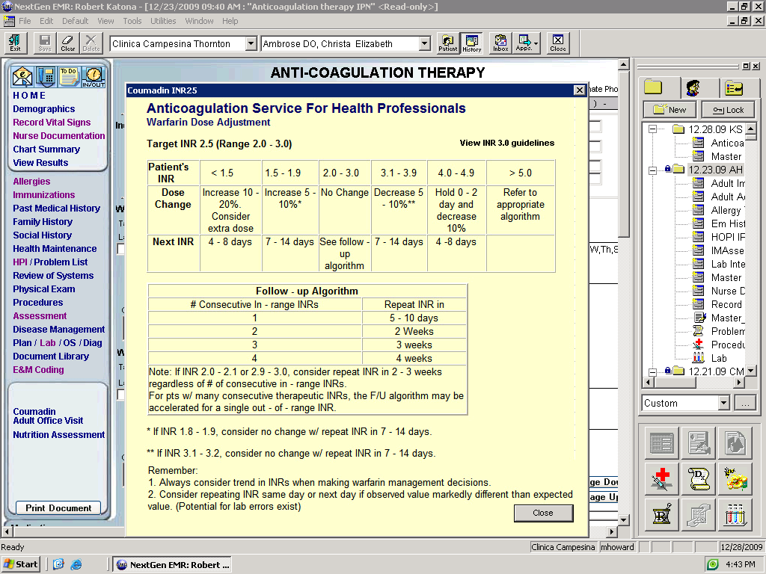

Consult provider for INRs <1.5 or >5.0



* In some cases **higher doses** of Coumadin are indicated. This will be determined by the provider and the range will be clearly documented on the template. Provider must also document reason/diagnosis in the Alert section of the Anticoagulation Template.
* Use the following dosing charts. If the range prescribed is higher than 3.0-4.0, consult provider.

|  |  |  |  |  |  |  |
| --- | --- | --- | --- | --- | --- | --- |
| **If pt’s target range is:** | **And pt’s current INR is:** | | | | | |
| 2.5-3.5 | <2.0 | 2.0-2.4 | 2.5-3.5 | 3.6-4.4 | 4.5- 5.4 | >5.5 |
| 3.0-4.0 | <2.5 | 2.5-2.9 | 3.0-4.0 | 4.1-4.9 | 5.0-5.9 | >6.0 |
| Dose Change | Increase 10-20%. Consider extra dose. | Increase 5-10%.* | No change. | Decrease 5-10%. | Hold 0-2 days and decrease 10%. | Refer to provider |
| Next INR | 4-8 days | 7-14 days | See f/u algorithm. | 7-14 days | 4-8 days. |  |

` ` ` ``````` `

**Documentation in the Anti-Coagulation template.**

### *If pt’s Coumadin is being co-managed by a home health agency or other provider, document that agency’s information in the alert box. (This box is “sticky” and carries forward to the future encounters).

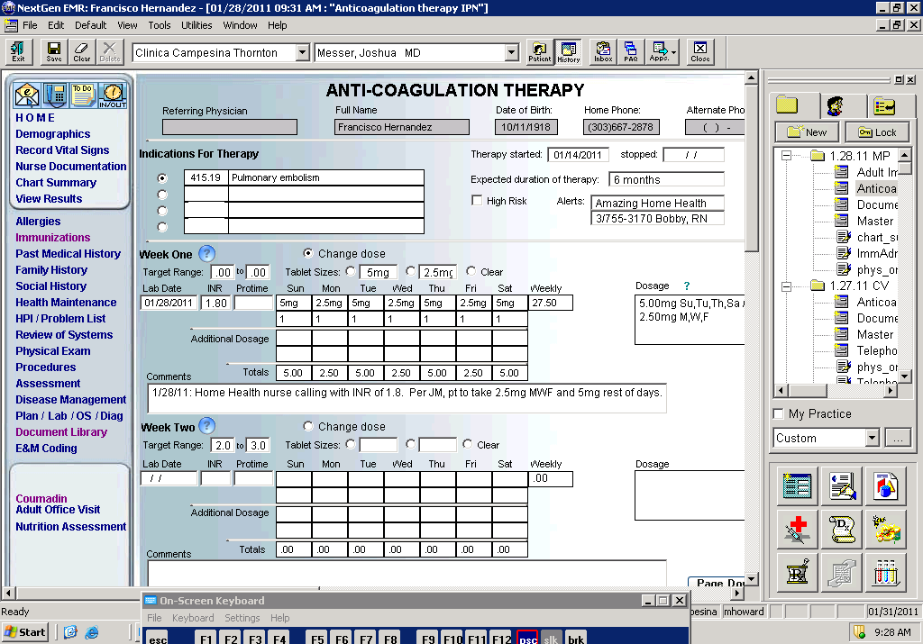

* Don’t use the template for Week Two dosing or Comments. This creates confusion for the next dosing adjustment and the Comments do not concatenate.

Document all of Above in Medical Record

and send task to Provider to sign off.

2.7 Rh Negative & Rhogam administration

Rhogram is administered to prevent isoimmunization in Rh negative women exposed to Rh positive blood thus preventing the risk of erythroblastosis fetalis in current or subsequent pregnancies.

**Subjective**

* Indications for initiating the Rhogam Nurse Protocol, document in HPI:
  + **Patient is Rh negative and 28 weeks gestation.** (Antibody screen will be done at INP and at delivery. It is not necessary to check another antibody screen prior to giving Rhogam).

OR

* + **Patient is Rh negative with a negative Rh antibody screen after SAB.**  Rhogam must be given within 72 hrs of SAB (onset of bleeding).

OR

* + **Pt is Rh negative with a negative Rh antibody screen after bleeding during pregnancy.** Must be given w/in 72 hrs of onset of bleeding.
* Document allergies.
* Screen patient for **recent live virus vaccination** (within the last 4 weeks; MMR, Varicella)**.**
  + Rhogam may interfere with efficacy of vaccine. Patient may still receive Rhogam if needed but a titer may need to be drawn later to determine if recent vaccine was effective. Live vaccines given immediately prior to Rhogam administration may require repeat vaccination.
* If father is known to be Rh negative, Rhogam is not required as baby will also be Rh negative. However, patient must provide proof of this. If provided, scan in to EMR.

**Objective**

* Patient shows no acute distress.

# **Assessment**

* Rh isoimmunization, unspecified episode. ICD-9: 656.10 Status: Follow-up

# **Plan**

* Discuss with patient that **adverse reactions** are infrequent.
  + The most common systemic side effects are HA, chills, fever, asthenia (muscle weakness), pallor, diarrhea, nausea/vomiting, arthralgia (joint pain), myalgia, malaise, dizziness, hyperkinesis, abdominal pain, back pain, hypotension, hypertension, increased LDH, drowsiness, vasodilation, pruritus, rash, and diaphoresis. Localized reactions at the site include induration, mild pain, redness, and swelling.
* **Fill out and give insert to patient,** remind to keep with medical records and/or bring to hospital for birth.
* Pt should a**void receiving a live virus vaccine** (see above) for 6 months following Rhogam administration.
* **Order today’s injection** in Office Services, Misc. Drugs. Use pregnancy as the assessment.
  + **Rhogam Injection, Each**
  + **Rhophylac 1500IU/300mcg (1 prefilled 2ml syringe)**
* **Administer medication**
  + Remember to save lot # and expiration date for EMR!
  + Bring Rhogam to **room temperature** before administration.
  + Inject IM using 1” needle into deltoid muscle or anterolateral portion of the upper thigh. Avoid gluteal muscle as a routine injection. site due to risk of sciatic nerve injury.
* Observe patient for 20 minutes after administration.
* **Remind currently pregnant** **patient** that after birth, baby’s blood type will be tested and patient will receive a **2nd Rhogam injection** within 72 hours of delivery if baby’s blood is Rh+.
* **Document in the following 3 places**:
  + - Plan Template: “Rhogam administered as per RN protocol.”
    - Nurse Documentation: lot #, expiration date, and site of injection
    - *OB Lab Results section of Obstetric Office Visit: Document that patient is Rh- under Type and Screen results. This will make “Rhogam” pop up at the bottom of the 28 WEEK LABS column. Input date under “Rhogam, Administered____________. Please be sure to click the SAVE button to the right after entry.

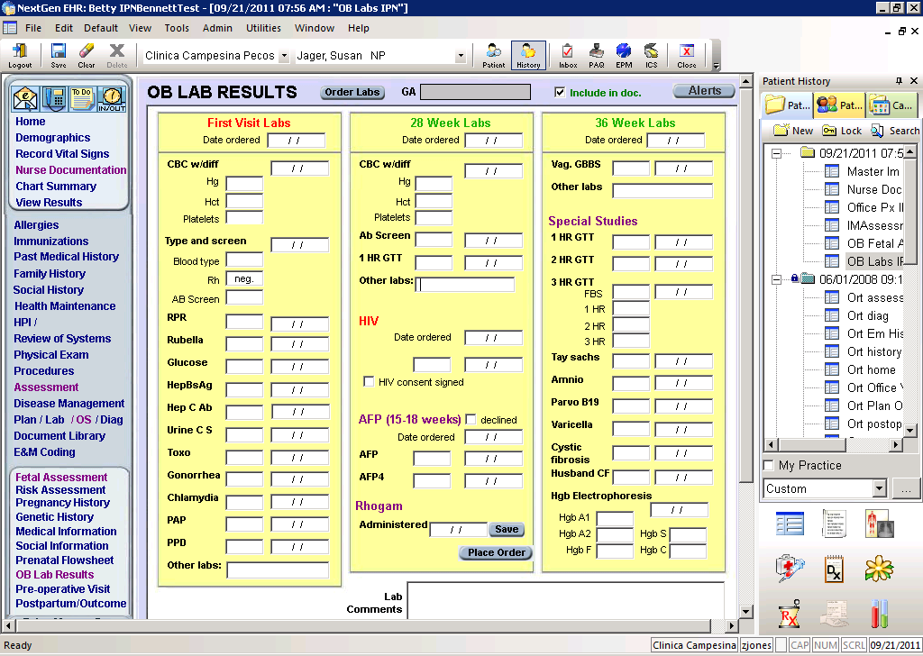

Ensure all of Above is Documented in Medical Record and send to pcp for notification.

# **General Information & Interesting Facts**

* Prior to the development of anti-D immune globulin, (which started around the 1960s), approximately 16 percent of Rh(D)-negative women became alloimmunized after two deliveries of Rh(D)-positive ABO compatible infants. This rate fell to 2 percent with routine postpartum administration of a single dose of anti-D immune globulin and was further reduced to as low as 0.1 percent with the addition of routine antenatal administration in the third trimester. However, Rh(D) alloimmunization has not been eliminated. Reasons for continued emergence of sensitized pregnancies include both failure to administer anti-D immune globulin in accordance with published guidelines and sensitization in early gestation before routine third trimester antenatal anti-D prophylaxis
* All women should be tested at the initial prenatal visit for Rh status. A positive test means that the fetus is at risk for hemolytic disease, not that it has occurred or will develop**.**
* Practice guidelines in the United States recommend that anti-D immune globulin be administered at 28 weeks gestation, with a 300 microgram dose. This practice reduces the incidence of antenatal alloimmunization from 2 to 0.1 percent as 1 (one) 300 microgram dose at 28 weeks antepartum is enough to suppress the immune response to as much as 15 mL of Rh+ blood. An additional dose at 72 hours postpartum is also recommended, which confers the same amount of protection.
* Anti-D immune globulin is a sterile solution containing IgG anti-D (anti-Rh) manufactured from human plasma. Although once produced from the plasma of sensitized women, the decreasing prevalence of Rhesus disease has necessitated the use of male donors who undergo repeated injections of Rh(D)-positive red cells to develop high-titered polyclonal anti-D plasma.
* Some Jehovah’s Witnesses will refuse to receive Rhogam as it is derived from human plasma.

References: “Prevention of Rh (D) Alloimmunication;” “Rho (D) Immune Globulin (Intramuscular): Drug Information,” Uptodate, 2011

2.8 1-Hour Glucose Tolerance Test (GTT)

**Assessment**

* Review 1-hr glucose tolerance test results. Screening typically occurs at 24-28 weeks gestation.
  + **<135 mg/dl**: no further testing required. No additional action expected.
  + **≥ 135 mg/dl**: requires a 100 gram 3-hour glucose tolerance test. See below.
  + **≥ 200 mg/dl:** patient has gestational diabetes. (per Uptodate) See below.
* See the [Colorado Collaborative Guidelines for Gestational Diabetes](http://www.coloradoguidelines.org/pdf/guidelines/gestationaldiabetes/gdm_guideline_short.pdf) for additional information.

# **Result ≥ 135 mg/dl:**

* **Management:**
  + Requires a 100 gram 3-hour glucose tolerance test.
  + Contact patient to schedule a 3-hour GTT for as soon as patient is available for appointment.
  + Schedule the following 2 appointments:
    - MA visit, first morning appointment slot.
    - Provider, ensure routine appointment scheduled
* **Patient Education:** 
  + The diagnostic test for GDM is a 100-g, 3-hour glucose tolerance test in a fasting state.
  + Plan on being in clinic for approximately 3 ½ hours
  + No food or beverage 8 hours before test (may drink water only.)
  + Drink glucose solution in less than 5 minutes.
  + During the test:
    - No smoking, eating, or drinking
    - Remain at rest
    - May not leave clinic
    - Blood will be drawn at arrival and every hour after drinking glucose, for a total of 4 blood draws.
  + May want to bring a snack to consume *after* testing completed.
  + Results will be available 1-2 days after testing.
* **Documentation:**
  + Document management plan/education in telephone template.
  + Task provider notifying of positive results, scheduled appointments, and f/u plan.
  + Concatenate telephone template note.
  + Follow NG documentation instructions in this document:
    - Link to “Documentation for 1H GTT Results”

# **Result ≥ 200 mg/dl:**

* **Management:** 
  + Patient has gestational diabetes.
  + Schedule the following 2 appointments:
    - Provider, within 1 week of receiving 1hr GTT result.
    - Dietician, within 1 week of receiving 1hr GTT result, preferably on same day pt is seeing provider.
  + Provide education as below.
  + Task provider and dietician with results and follow up plan.
* **Patient Education:**
  + Patient will need an appointment with both the provider and dietician regarding blood sugar control, diet, and glucometer use.
* **Documentation**:
  + Document management plan/education in telephone template.
  + Task provider and dietician notifying of positive results, scheduled appointments, and f/u plan.
  + Concatenate telephone template note.
  + Complete documentation per instructions below:

Documenting 1-Hour Glucose Tolerance Test (GTT)Results

**Documentation:**

1. Document management plan/education in telephone template.
2. Task provider notifying of positive results, scheduled appointments, and f/u plan.
3. Document **results ≥135mg/dl** in **Lab Results** template.
   1. From Navigation Bar, click on “Prenatal Detail”
   2. Select “Lab Results” from top tabs
   3. Scroll down 24-28 week labs (see below for more detauls)

**3B**

**B**

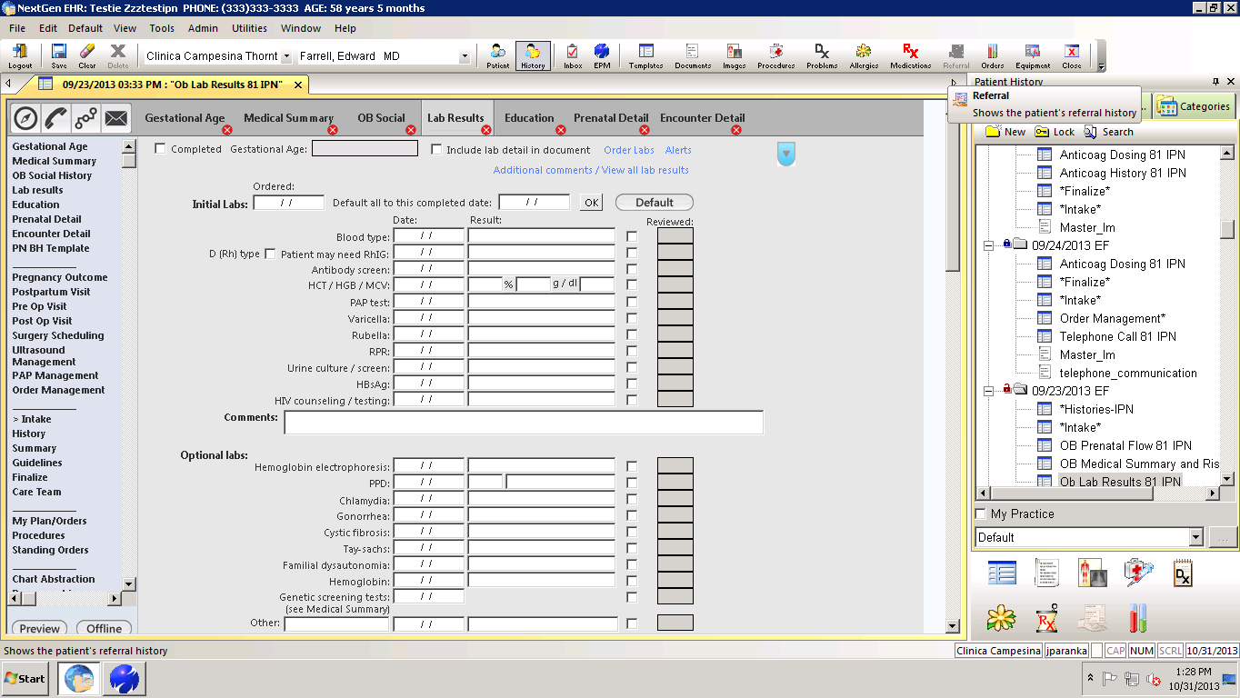

**3A**

1. Enter 1H GTT results
   1. Enter results in section titled “Diabetes Screen”

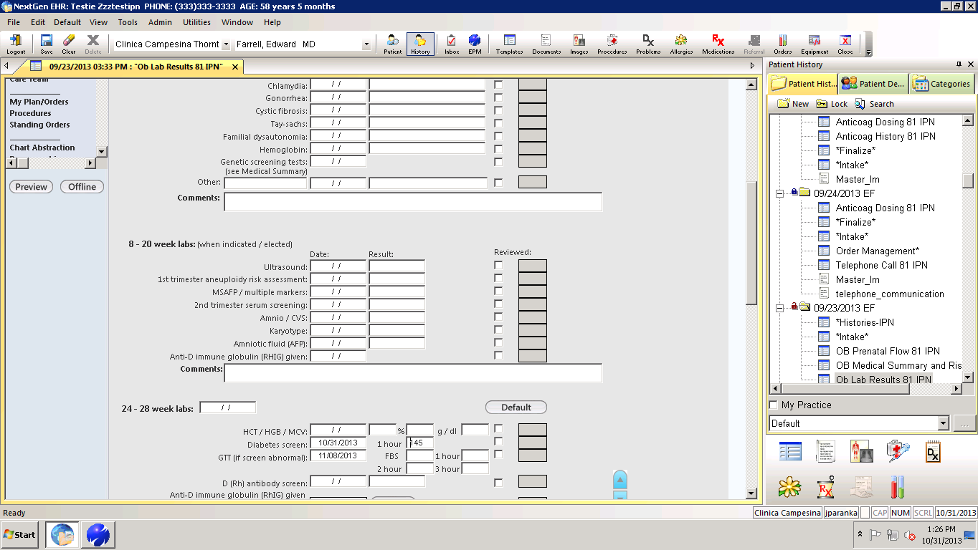

**4A**

1. Document **results ≥ 135 mg/dl** in the **Problem** section of the Prenatal Detail Flowsheet.
   1. From Nav Bar, click on “Prenatal Detail”
   2. Select “Add” from below Problem list
   3. Enter problem as “1H GTT results > 135” & detail of “3H GTT Scheduled”
   4. Save & Close

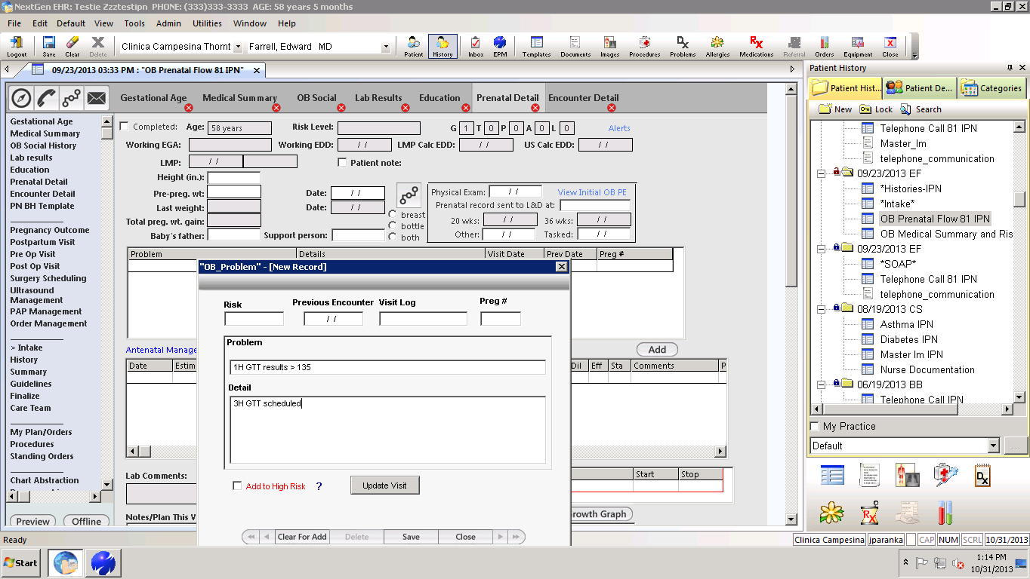

**5C**

**5B**

**B**

**5A**

**1A**

# **Result ≥ 200 mg/dl (pt has Gestational Diabetes per UpToDate)**

1. **Documentation**:
   1. Document as above in the Prenatal Detail Lab Results **AND**
   2. Click on “GDM” in the OB Problem Section
      1. This will create an entry in the OB Problem grid & increase the Risk Level automatically.

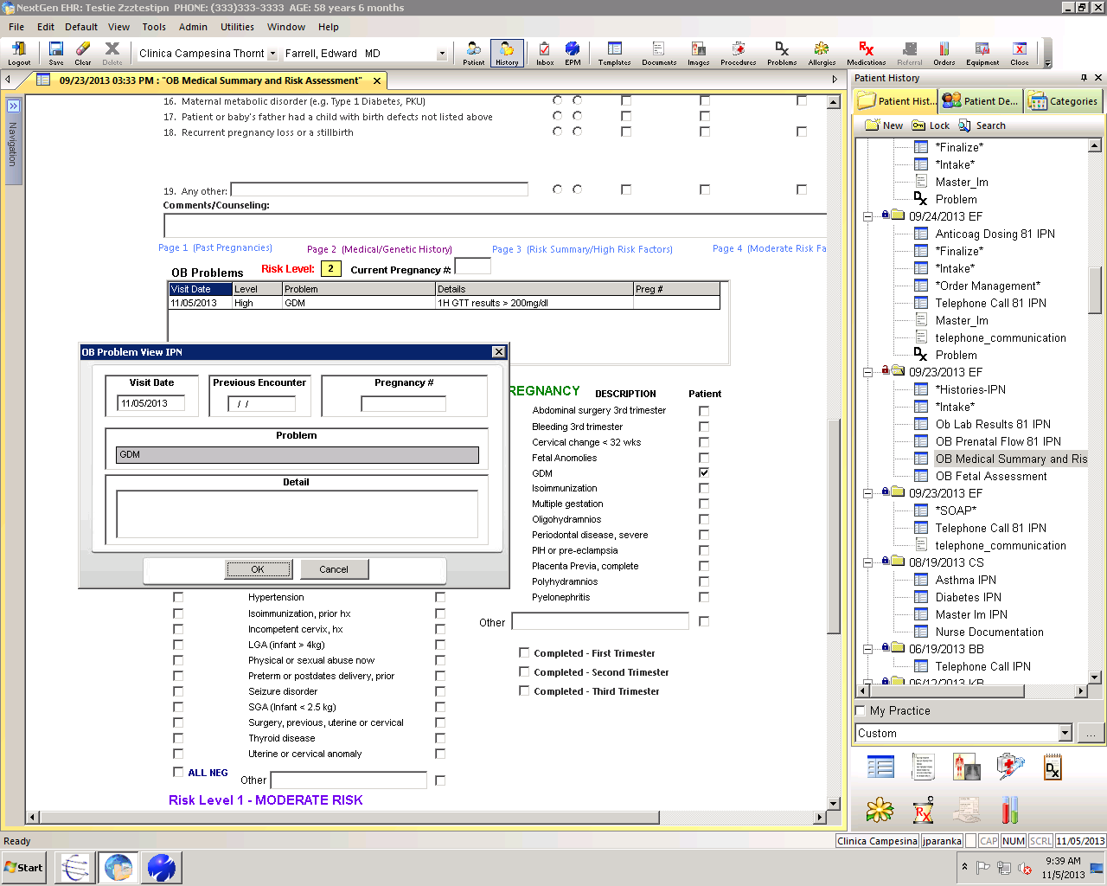

**6B**

**B**

3.1 Conjunctivitis

**Subjective**

* **Document:**
  + Presence, history and duration of watery, mucoid or purulent discharge from the eye, crusting of the eyelids in the morning, redness, and irritation of eyes.
  + Symptoms of allergies (i.e. runny nose, itchy watery eyes, sneezing)
  + Symptoms of upper respiratory infection (i.e. runny nose, cough, fever, sore throat)
* Exposure to other people with symptoms
* **Absence of eye pain, photophobia, significant vision changes or history** **of eye trauma**

# **Objective**

Acute conjunctivitis is usually a benign, self-limiting condition or one that is easily treated. There are three different etiologies for conjunctivitis: viral, bacterial, and allergic. Although most studies suggest that the majority of cases are bacterial, clinical experience suggests that most conjunctivitis is largely viral. Below are some pointers for being able to distinguish between the types:

* Bacterial
  + Usually **unilateral** in presentation
  + Thick, purulent, yellow, green or white discharge
  + Discharge located at lid margins and corners of eye and tends to re-appear within minutes of wiping
  + More common in children than adults
  + Redness or erythema
  + Patient will likely report that one or both eyes was “stuck shut” upon waking. (AM crusting) *This finding alone is not specific to bacterial conjunctivitis.
* Viral
  + Usually bilateral in presentation
  + Scant, watery or mucoserous discharge
  + Discharge not always immediately apparent; often clinician has to pull down lower lid to observe exudate
  + History of other URI symptoms (cough, sore throat, nasal congestion)
  + Patient may report “sandy, gritty or burning” feeling in one or both eyes
  + Report of AM crusting (eye “stuck shut”)
  + Erythema
* Allergic
  + Usually bilateral in presentation
  + Bilateral erythema often observed
  + History of seasonal allergies
  + Tearing or watery discharge
  + **Itching (this is the cardinal sign of allergic conjunctivitis)

**SIGNS AND SYMPTOMS WHICH REQUIRE THE IMMEDIATE ATTENTION OF A PROVIDER**

* Profuse, purulent discharge to the point where the amount of discharge is “striking”
* Eye is tender to palpation
* Generalized edema of the affected lid
* Visual changes
* Pre-auricular adenopathy
* Periorbital edema
* Foreign body sensation

If none of the above signs and symptoms of optic emergency are present, document the presence or absence of erythema and itching; type of discharge or drainage; associated symptoms; absence of conjunctival swelling or edema. Present patient to provider.

# **Appraisal:** Uncomplicated Conjunctivitis

# **Plan**

# Education (for Viral and therefore self-limiting conjunctivits):

If patient has other viral or allergy symptoms, they probably do not need treatment. Explain to patient viral vs bacterial illness and that as with other viral episodes, symptoms may persist for 10-14 days. Write an excuse for day care or school if needed. Advise warm moist compresses for crusts, hand washing to prevent spread. Provide reassurance that conjunctivitis is usually self limiting with no permanent effects. In addition, topical lubricants such as Dry Eyes can be suggested for allergic etiologies.

# **Treatment (for bacterial conjunctivitis**):

* Write an excuse for day care or school if needed.
* **Erythromycin Ophthalmic Ointment** ½ “ QID x 5-7 days. Warn patient or parent that ointment may blur vision for up to 20 minutes.

OR

* **Sulfacetamide Ophthalmic** **Drops** 10% 1-2 drops QID x 5-7 days
* Patients with bacterial conjunctivitis should expect improvement in discharge, redness, and irritation after 1-2 days.

*Call back for appointment with provider if:*

* If symptoms worsen or if they do not improve in 7 days.
* Call back for visual changes or eye pain.

**Bacterial Conjunctivitis**

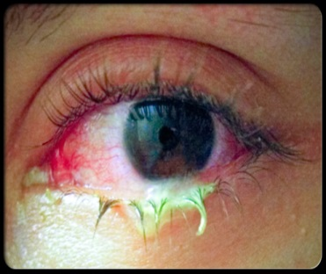

**Bacterial Conjunctivitis**

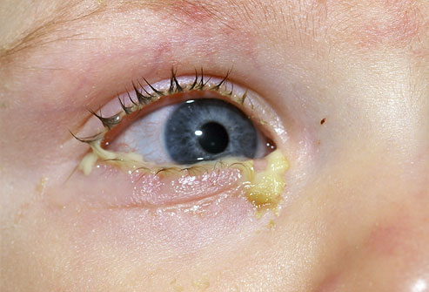

**Viral or Allergic Conjunctivitis**

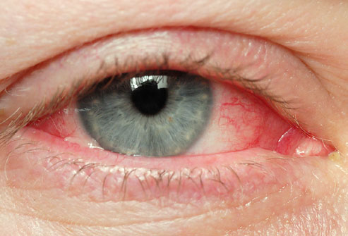

NOTIFY PCP: SEND COPY OF MASTER IM TO PCP

See below for QTS on charting

NextGen Documentation for Conjunctivitis Visit

1. Patient Intake
   1. Enter pt vitals & then select “Additional/Manage as Reason for Visit.
   2. Select “Eye Problems”

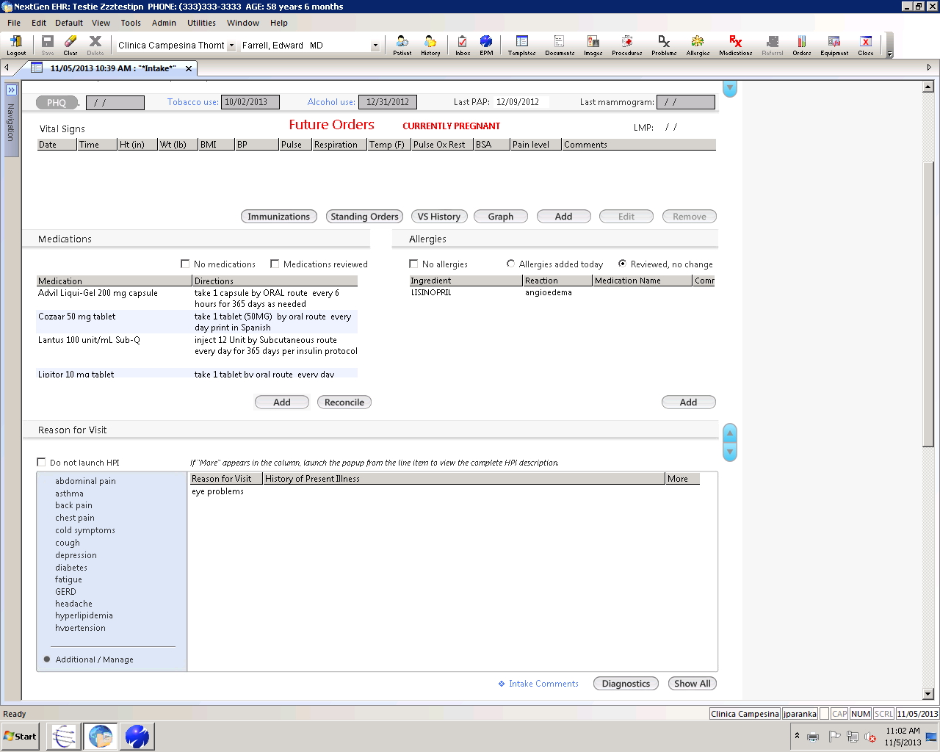

1. Quick Visit HPI/ROS
   1. Double click on reason for visit (eye problems) & complete quick visit template
   2. At a minimum, evaluate the items shown below (to enable differential dx for bacterial vs. viral vs. allergic conjunctivitis)

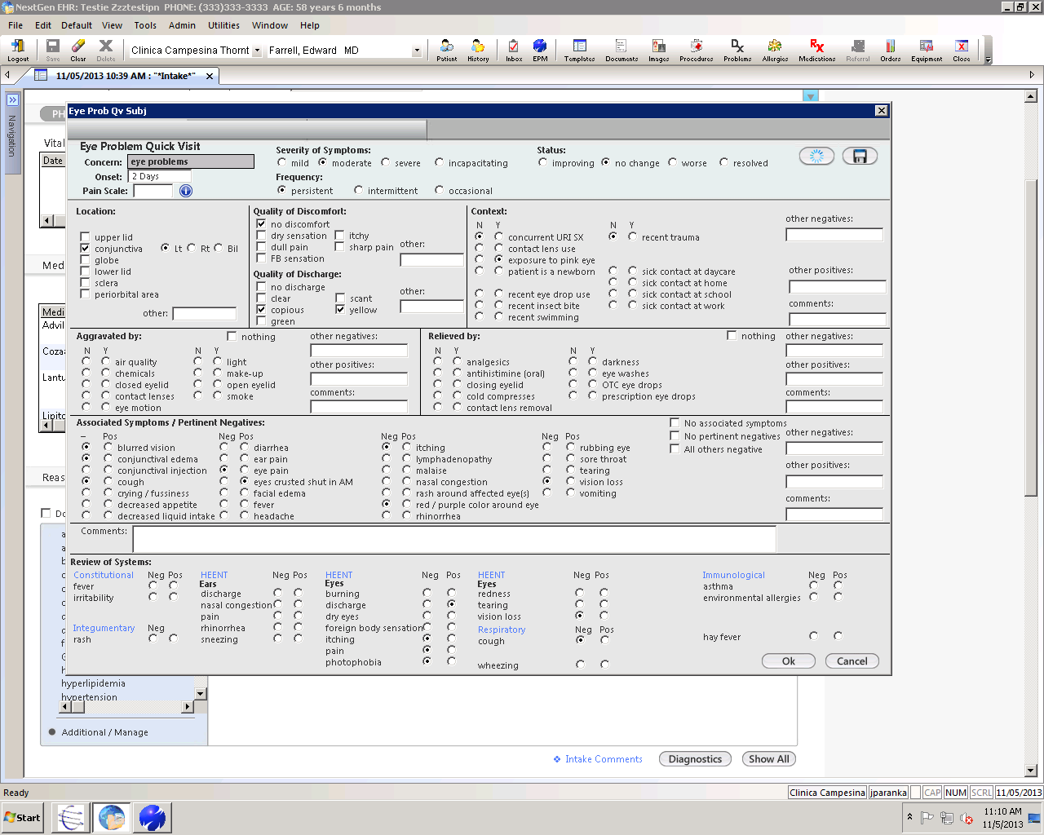

1. Determine diagnosis (per protocol instructions) & prescribe meds as appropriate.
   1. See P:\Committees\Nursing Services\policies and procedures being edited\Sec 3.1_Conjunctivitis_11.05.13.docx
2. Plan/Instructions
   1. Add assessment
   2. Document instructions
   3. Place Order
   4. Save & Close

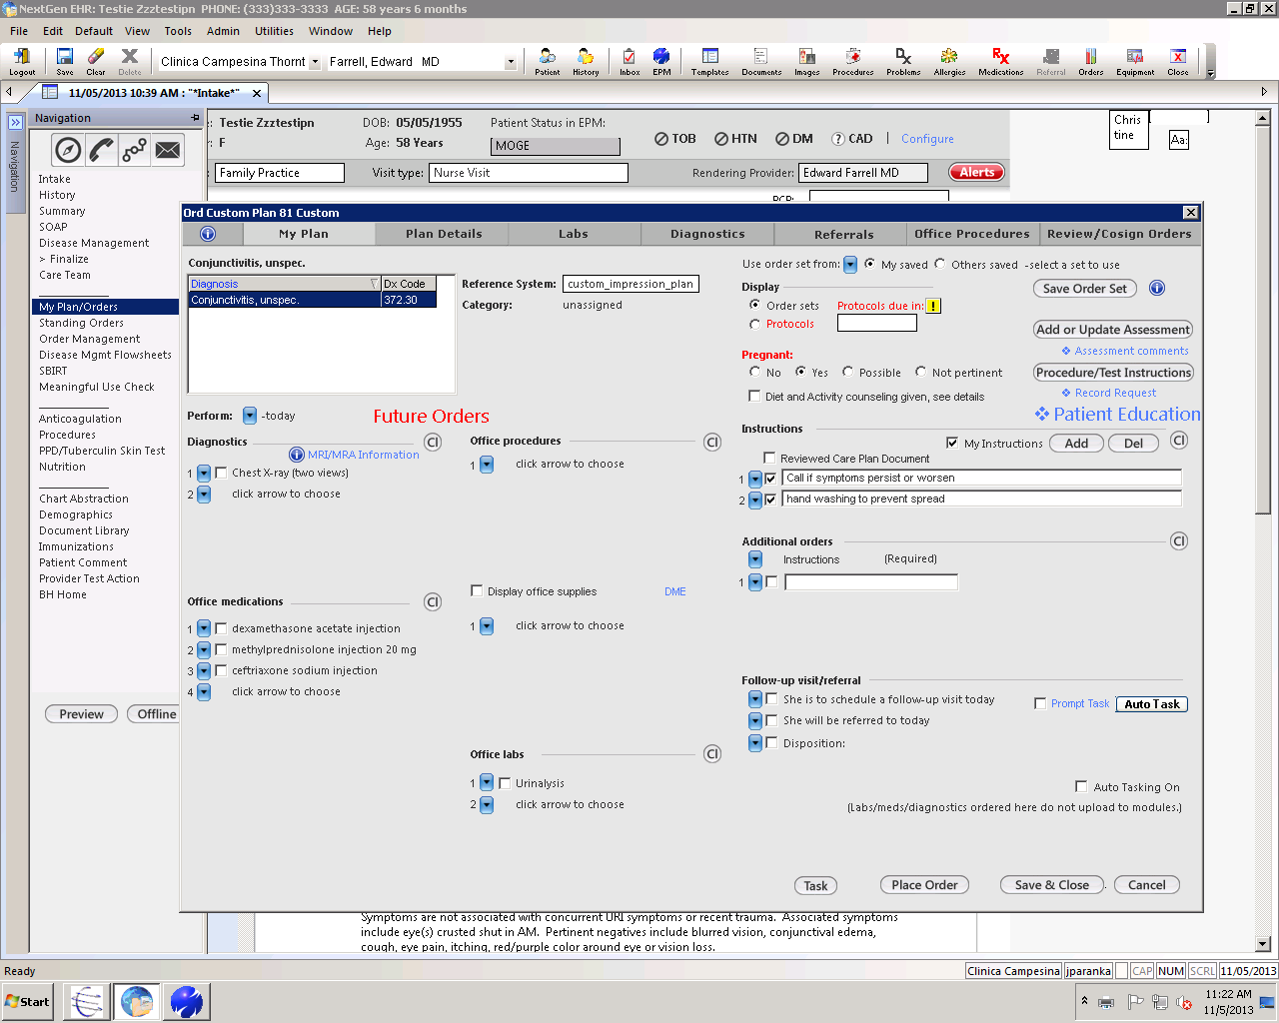

1. Finalize (if appropriate; if not “flipped” to a provider visit)
   1. Select “Finalize” Template
   2. Click “99211” for Nurse Visit
   3. Generate Note “Master Document” (change “Authenticated By” name to your own at bottom & save).
   4. Generate Patient Plan (Remove provider’s signature & change “Authenticated By” name to your own at the bottom, save).

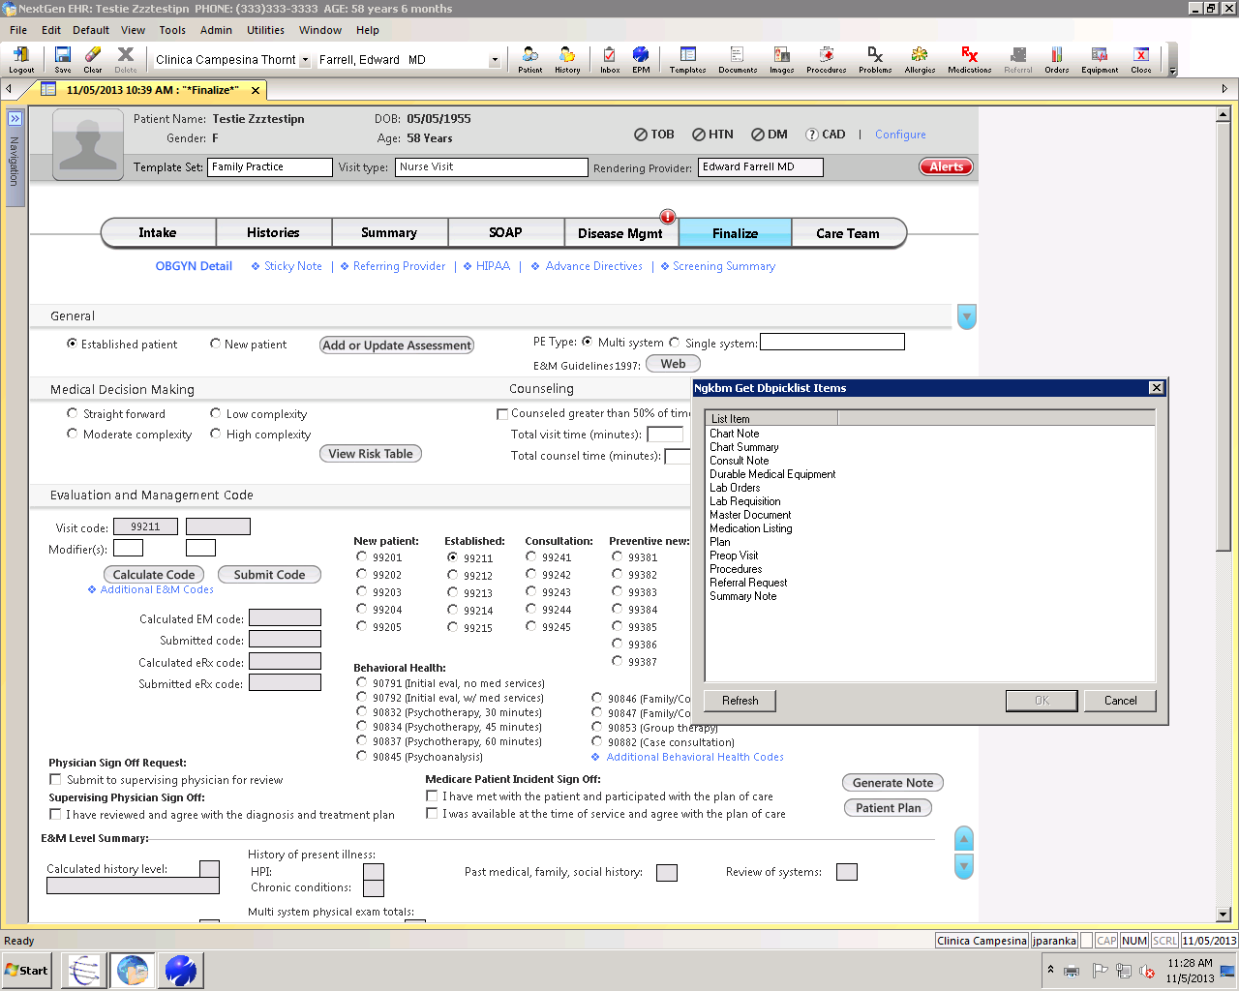

3.2 Children Over 12 Months and Adults With Ear Pain

***Note: QTS for charting included at END of this Document***

**Subjective**

* Current pain, drainage from ears, recent URI, fever, decreased fluid intake, listlessness. Pulling on ears or vomiting in a child not yet old enough to verbalize.
* History of recent or recurrent ear infections, recent antibiotics, teething or extended exposure to water. Consult provider if recurring ear infections, purulent conjunctivitis or recent antibiotic use (within last 30 days).
* Document history of allergies to antibiotics

# **Objective**

* Describe general condition of child, i.e. no acute distress (NAD) or playful or alert
* Document vital signs
* Note condition of the external auditory canal (EAC) and compare the drums in each ear
* Note movement of the auricle and tragus may be painful in otitis externa
* Document if nose has mucoid nasal discharge.
* Neck should be supple
* Fontanel should be flat but not sunken
* Respirations should be noted as unlabored, even if breathing is rapid secondary to fever

**Assessment**

* Otitis media NOS, 382.9 OR Otitis media, acute with rupture of ear drum, 382.01

# **Treatment**

* Refer to chart from Uptodate (below) to determine if observation or treatment is indicated. Observation can include providing a prescription for antibiotics to use if symptoms do not improve or worsen.
* **First Line Agents:**
  + AMOXICILLIN(Amoxil**)** 80mg-90mg kg/day, to a max of 3 grams per day or 90 mg/kg per day, whichever is less. Dose should be divided Q8 hrs (TID). In addition please see guidelines by age:
    - AMOXICILLIN, x 10 days for kids 12-24 months old, divided Q8 hrs (TID)
    - AMOXICILLIN, x 7 days for kids >2 years old up to adults**,** divided Q8 hrs (TID)
* **Second Line Agents: (if non-*type 1 mild allergic reaction** to Amoxicillin):
  + CEFDINIR (Omnicef) 14mg/kg/day, max 600mg, divided into 1-2 doses x 10 days for 12-24 months old.
  + CEFDINIR (Omnicef) 14mg/kg/day, max 600mg, divided into 1-2 doses x 7 days for **>**2 years old-adult.
* **Second Line Agent: (IF type 1 allergic reaction** to Amoxicillin):
  + AZITHROMYCIN (Zithromax) 10mg/kg/day for day 1, 5mg/kg/day for days 2-5,for **kids >12months.**

* A type 1 reaction to a medication is defined as anaphylaxis and uticaria.

* Always include symptomatic treatment for pain or fever with acetaminophen or ibuprofen as appropriate for age/weight. See Tylenol/Ibuprofen dosing chart by clicking here.
* **Ear drops for acute pain: Antipyrine/benzocaine otic** 5.4%/1.4% solution. 2-4 gtt in ear(s) q1-2hrs prn for acute otitis media pain. (Clinica is $15.75 for 15ml or Wal-mart $4 for 10ml bottle).

# **Education**

* Babies should be off the bottle by age 1 year, avoid exposure to second hand smoke
* Feed infants in semi-upright position, not completely horizontal
* Otitis media can progress to mastoiditis, a serious condition needing hospitalization
* All children less than 2 years old need a follow up appointment in 3-4 weeks
* If no improvement in 24 hours after onset of treatment, parent needs to call back for an appointment
* Remind parents that over the counter preparations for cold symptoms should not be given to children under 2 years old

# **If Co-Visit**

* Make sure all of the above is documented. Concatenate note.
* Present to provider. Confirm antibiotic choice and dosing with provider.
* Adjust appointment properties as per co-visit procedure. Immediately cut and paste appointment into provider’s schedule so they can access patient’s chart and code/concatenate visit after reviewing nurse’s documentation and completing visit.

*Call back for appointment with provider if:*

* Persistent fever
* New drainage from ear or increased swelling in region of ear/mastoid
* Not improving with antibiotics after 24 hours
* Decreased PO intake, listlessness, vomiting

**Document all of above in Medical Record (see QTS below) and send task to PCP as FYI.**

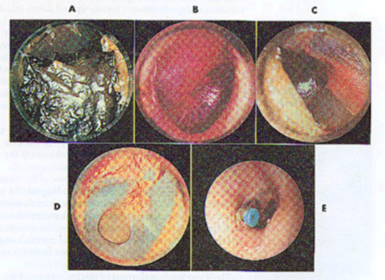

### FIGURE 10-15: A: Tympanic membrane partially obscured by cerumen. B: Bulging tympanic membrane with loss of bony landmarks. C: Perforated tympanic membrane. D: Perforated tympanic membrane that has healed. E: Tympanostomy tube protruding from the right tympanic membrane.



### FIGURE 11-16: Healthy Tympanic Membrane

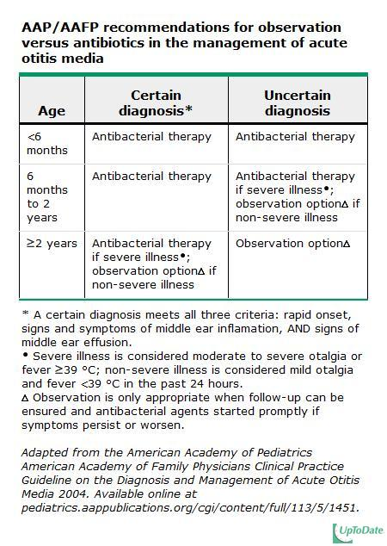

NextGen Documentation for Otitis Media:

1. Patient Intake
   1. Enter pt vitals & then select Earache as Reason for Visit.

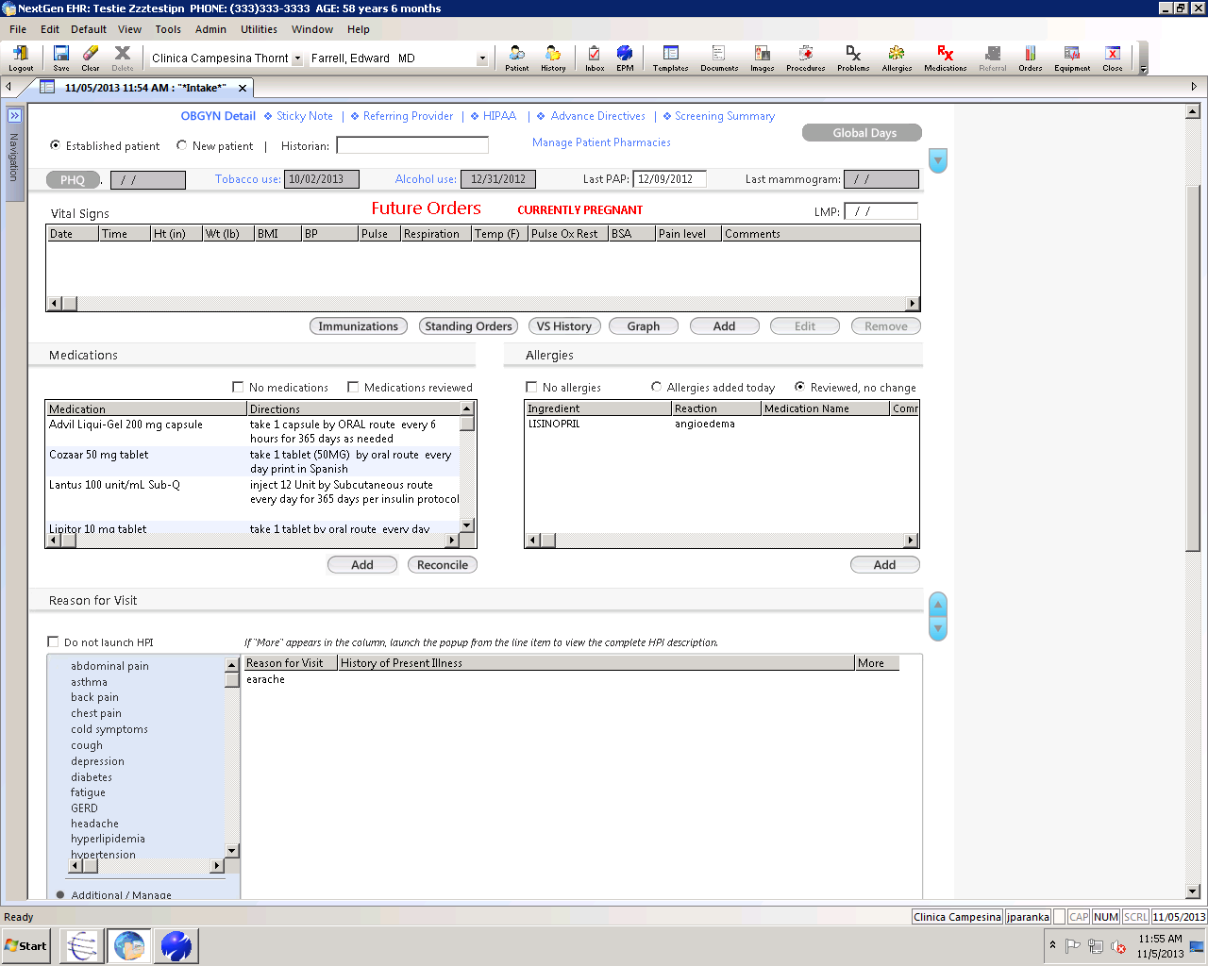

1. Quick Visit HPI/ROS
   1. Double click on reason for visit (eye problems) & complete quick visit template
   2. At a minimum, evaluate the items shown below

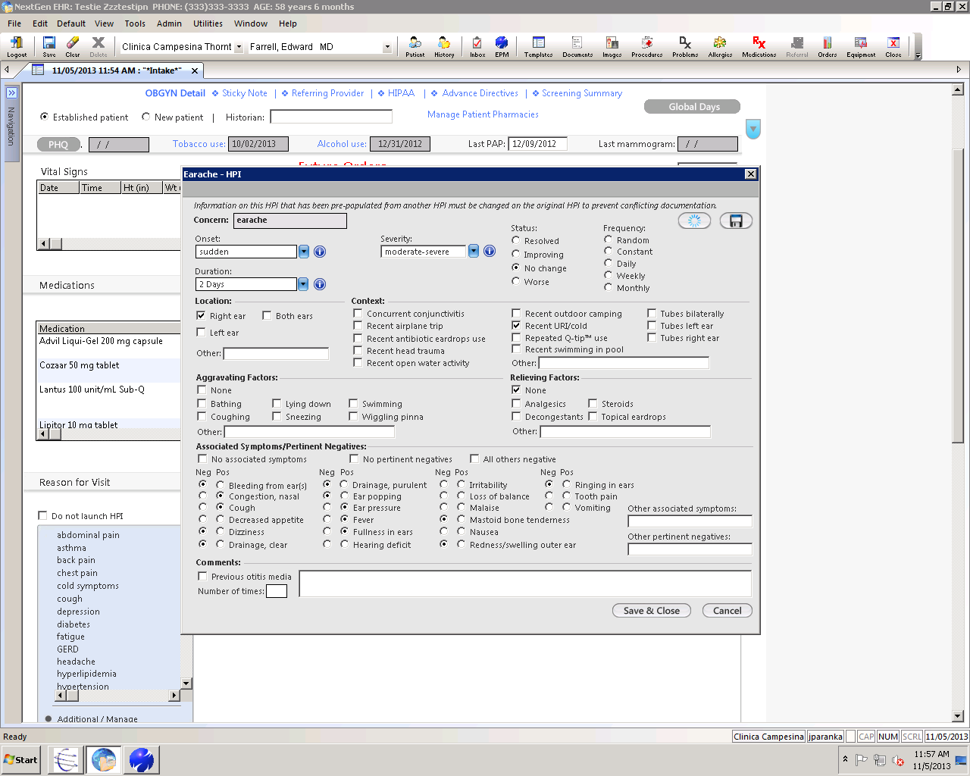

1. Determine diagnosis (per protocol instructions) & prescribe meds as appropriate.
   1. See P:\Clinical\Nursing Protocols\Section III_Nurses\Sec 3.2 Otitis Media 10.15.11.doc
2. Plan/Instructions
   1. Add assessment
   2. Document instructions
   3. Place Order
   4. Save & Close

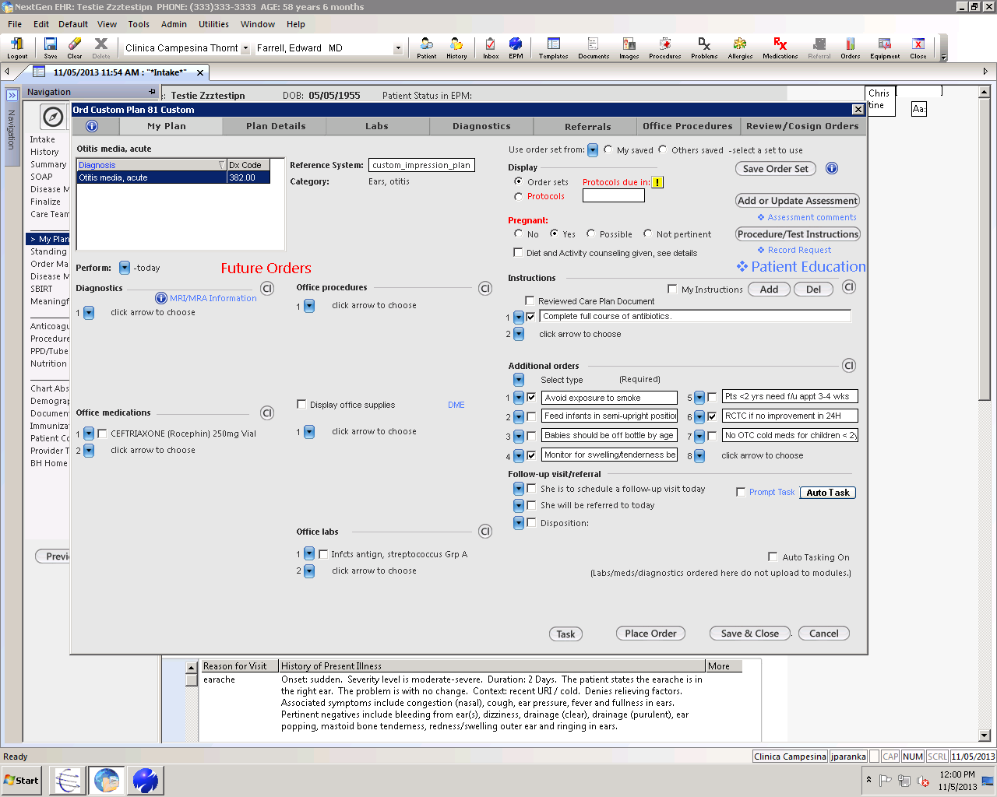

1. Finalize (if appropriate – if not “flipped” to provider visit)
   1. Select “Finalize” Template
   2. Click “99211” for Nurse Visit
   3. Generate Note “Master Document” (change “Authenticated By” name to your own at bottom & save).
   4. Generate Patient Plan (Remove provider’s signature & change “Authenticated By” name to your own at the bottom, save).



3.4 Head Lice

**Subjective**

* Who diagnosed head lice?
* What remedies has the patient already tried?
* Are other kids at home exposed?

# **Objective**

* Appearance of nits (eggs)- gray oval bodies firmly attached to hair follicles most likely at nape of neck
* Present to Provider

# **Assessment:** Head Lice 132.0

# **Plan/Treatment**:

* + **First Line Agent:**
    - PYRETHOIDS/PYRETHRINS (PERMETHRIN TOPICAL FORMULAS): see instructions below.
      * Topical agents containing Permethrin are the preferred initial therapy for our patient population due mainly to cost. *Lotions containing pyrethrins as well as 1% solutions are available OTC whereas the 5% solution is available by prescription only. As research has not shown there to be a difference in efficacy between the concentrations, most patients can be encouraged to start with over the counter therapy due to the difference in cost ($7-$10 Walmart vs, .33-4% Permethrin in the Clinica pharmacy at $22.09).
      * Pyrethrins are made from an extract of the chrysanthemum flower and have extremely low mammalian toxicity. Allergic reactions are also rare.
  + **Second Line Agents:**
    - BENZYL ALCOHOL 5% (OTC): Apply 120 - 180 mL by topical route to dry hair, completely saturating hair and scalp. After 10 minutes thoroughly rinse with water. Repeat in 7 days.
    - MALATHION .5% (Ovide): Apply by topical route to dry hair and rub gently until the scalp is thoroughly moistened and let dry naturally; shampoo after 8-12 hours.
      * These two agents are largely recommended in the event of Pyrethin resistance, which is growing in some areas. Benzyl alcohol averages about $20 a bottle and is available over the counter but has to be ordered first by the pharmacist. Evidence shows that Malathion is more effective than Permethrin in general, but it is extremely costly.

*NOTE: **Lindane** requires a prescription. It has been shown to be extremely neurotoxic and carries a black box warning. It is only used in very specific situations by provider discretion.

*For Permethrin and Benzyl Alcohol, which are both over the counter, please remember to order in the NextGen med module if patient would like to pick up at our pharmacy.

# **patient education (Permethrin):**

* Shampoo hair thoroughly, rinse and towel dry. Apply solution leaving on for 10 minutes. Rinse.
* Use fine-toothed comb to remove dead lice and nits; rinse comb in vinegar after treatment
* Repeat treatment in 8-10 days to remove any hatched nits
* Wash brushes and combs with hot water
* Wash or dry-clean clothing and linens (garments can be stored for 30 days and will no longer be infested)
* Vacuum carpets, mattresses, and upholstery
* Everyone in the house should use treatment if symptomatic or if there is bed sharing

**INTERESTING FACTS/ ADDITIONAL INFORMATION:**

* Lice infestation is not specific to socioeconomic background however it affects mostly children: girls more than boys and whites more than blacks
* With the exception of the common cold, lice affects more elementary school children than all other communicable diseases combined
* Modes of transmission include headphones, shared combs, towels, the transfer of clothing on adjacent hooks in school cloakrooms
* Lice cannot jump, fly or use pets as vectors
* Lice infestation is usually asymptomatic
* *It is not recommended that children miss school due to lice because of the high rate of asymptomatic colonization. Rather prompt treatment is emphasized after which the child can immediately return to school
* Efforts to eliminate lice by shaving the head or applying thick oily agents like butter, Vaseline, have not proven effective
* A lice infestation can be traumatic for some patients, causing obsessions or delusions about re-infestation

NextGen Documentation for Head Lice:

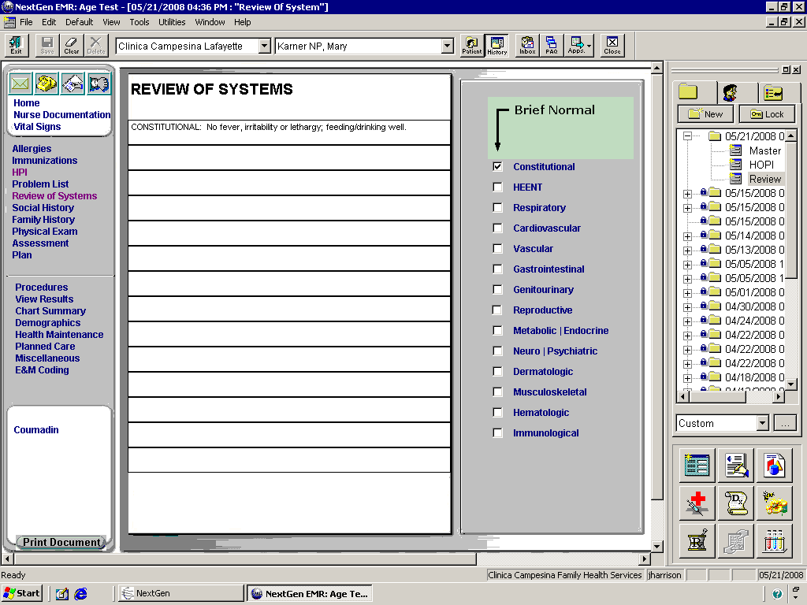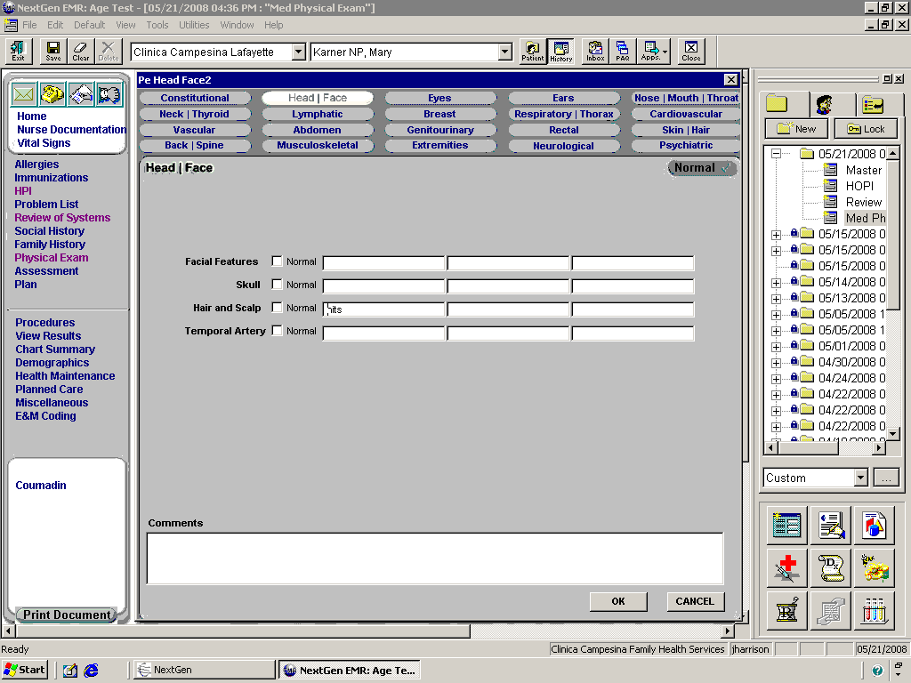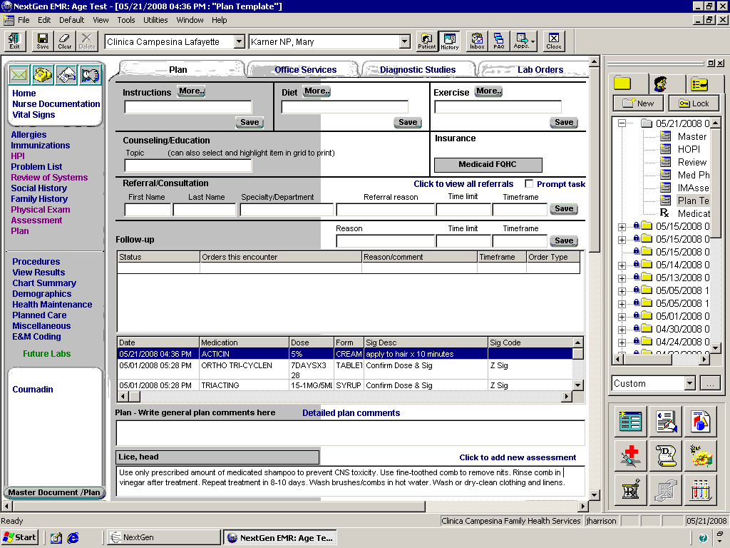

SEND COPY OF MASTER IM TO PCP FOR NOTIFICATION

3.5 Infant Under One Year Presenting with Thrush

**Subjective**

* Duration of symptoms
* Appetite normal or slightly decreased
* Normal urine output
* Change in behavior, signs and symptoms of pain (ie. not eating normally or crying when eating in an infant)
* Document Allergies

# **Objective**

* Mouth: irregular white plaques with or without an erythematous base on the buccal or lingual surface of the mouth
* Removal of plaques may cause bleeding
* Diaper/Inguinal Area: confluent erythema, discrete erythematous papules with superficial scales, and satellite lesions. See photo below.
* Present patient to provider

# **Assessment**: Thrush (112.0) or Thrush, Newborn (771.7)

# **Treatment (oral candida):**

* NYSTATIN ORAL SUPSENSION (100,00 units per mL)

Dispense 0.5mL inside each cheek 4-6x per day between feeds

* FLUCONIZOLE (DIFLUCAN) PO 3mg/kg once daily x 7 days

Treatment for resistant cases of thrush

**TREATMENT (DIAPER DERMATITIS):**

* NYSTATIN (requires Rx)
* MICONAZOLE, OR CLOTRIMAZOLE TOPICAL APPLICATIONS

-Apply after each diapering

# **patient education**:

* Good oral hygiene. For infants this includes boiling bottles and pacifiers
* Do not put anything in an infant’s or child’s mouth that has already been in someone else’s
* *If symptoms continue or persist, patient needs appointment.* Invasive fungal dermatitis can actually lead to systemic disease which has a very poor outcome.

*Call back for appointment with provider if:*

* If symptoms continue after treatment
* Patient has decreased urine output (< than 6 wet diapers per day) for infants less than 6 months.
* Patient’s appetite is significantly decreased

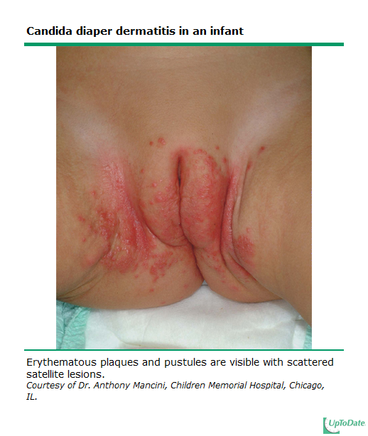

NextGen Documentation for Oral Thrush:

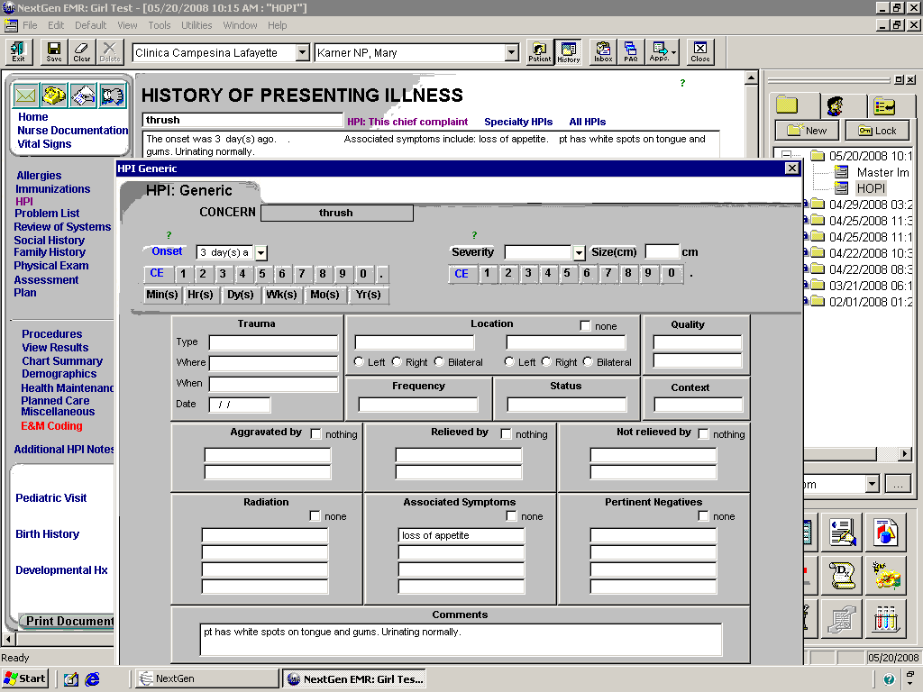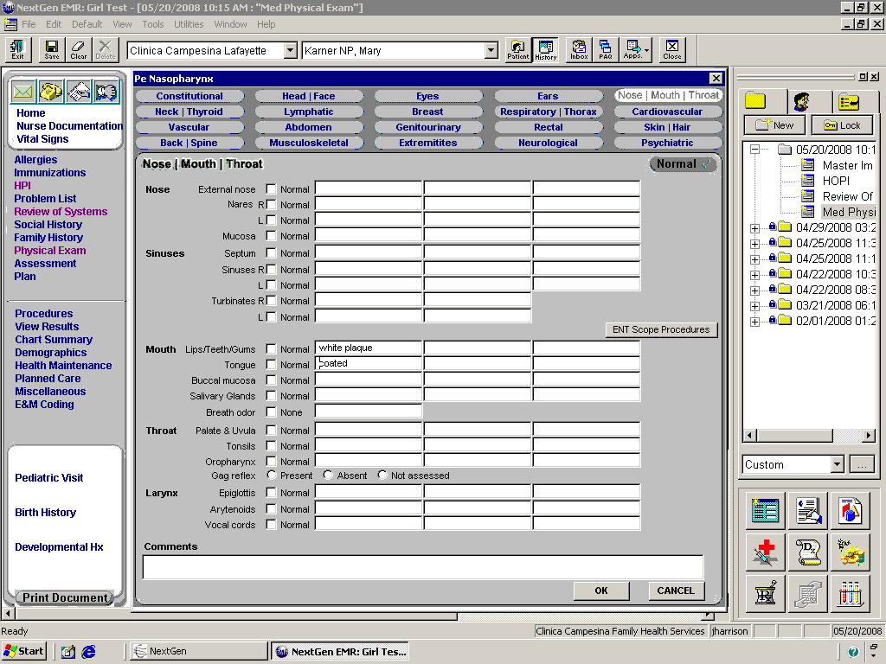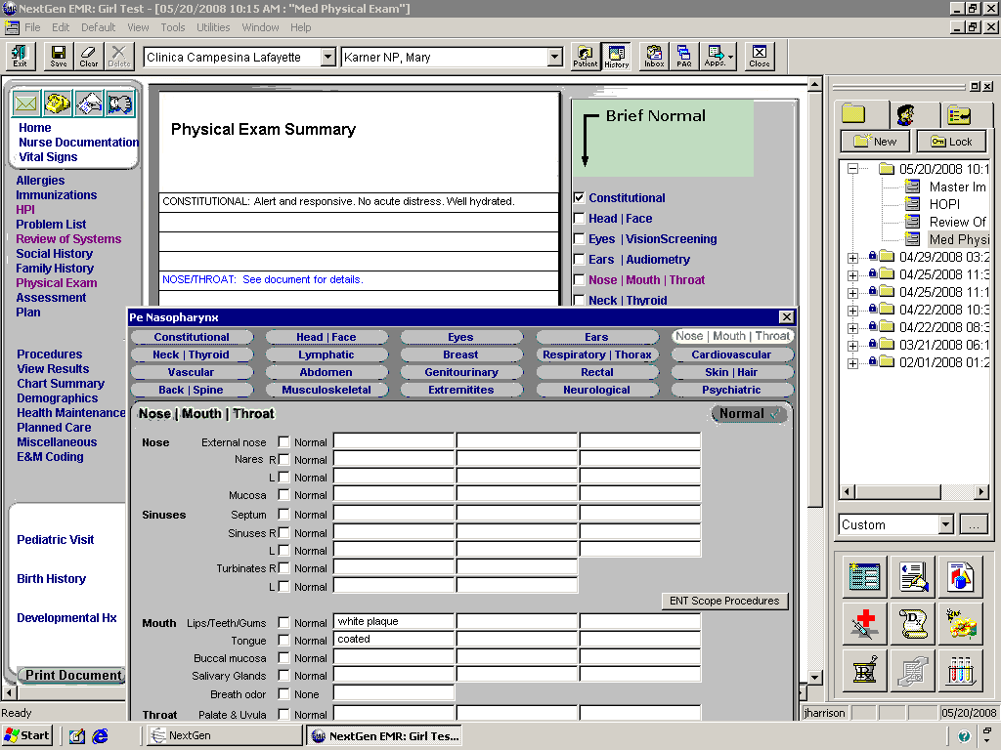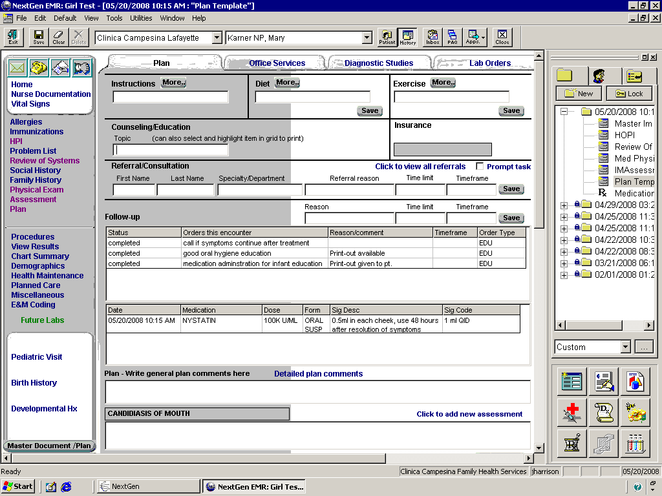

3.6 Uncomplicated Urinary Tract Infection Nurse Visit

Patient is considered complicated if they are: male, child, ill-appearing, fever, nausea, vomiting, flank pain, pregnant with recurrent infection. For any of the above, consult provider.

**Subjective**

* Frequency, urgency, dysuria, hematuria, pyuria, fever and chills, nausea or vomiting.
* History of recurrent or previous bladder infections, urinary tract surgery, renal stones or other problems
* Document allergies to medications, other medical problems such as diabetes, etc.
* Document last menstrual period and contraceptive method for women

**Objective**

* Document vital signs and absence of fever
* Check for no CVA tenderness, and that bowel sounds are normal and abdomen is non-tender
* In-house office service: UA Dipstick, V72.6 Laboratory Examination for leukocytes, nitrites, and/or hematuria
* Prepare and order “Culture, Urine” if indicated, (urine culture kit, grey top tube).

**Assessment**

* Cystitis, Acute, 595.0 OR Urinary Tract Infection, Acute, 599.0

# **Treatment**

* Consult provider if patient is allergic to antibiotics.
  + **ADAMS AND BOULDER COUNTY:**
    - **Non pregnant patients:**
      * NITROFURANTOIN monohyd/m-cryst (dual release, extended release, Macrobid)100mg TAB 1 BIDX5D #10 (about $16 @ Clinica)

**OR**

* + - * NITROFURANTOIN macrocrystal (regular release, Macrodantin) 100mg TAB 1 QIDx5D #20 ($12 @) Walmart)

**OR**

* CIPROFLOXACIN (Cipro) 250mg TAB 1 BIDX3D #6
  + - Per antibiogram data, these are all acceptable first line treatments for E. Coli.
    - **Pregnant patients:**
    - **Notify provider if pt has had >1 positive urine culture during this pregnancy** *If bacteria is GBS, note in prenatal* *Problem List & Labs. Task provider to notify positive GBS and to determine if treatment necessary. See below for documentation.* 
      * NITROFURANTOIN monohyd/m-cryst (dual release, extended release, Macrobid)100mg TAB 1 BIDX5D #10 (about $16 @ Clinica)

(Not during 36wks gestation to 30 days postpartum)*see below

**OR**

* + - * NITROFURANTOIN macrocrystal (regular release, Macrodantin) 100mg TAB 1 QIDx5D #20 (about $12 @) Walmart)

(Not during 36wks gestation to 30 days postpartum)*see below

* + - * Per BCH antibiogram, first-line treatment for **E.coli only.**

**OR**

* + - * AMOXICILLIN (Amoxil) 500mg TAB 1 BIDX5D #10

**OR**

* + - * CEPHALEXIN (Keflex) 500mg TAB 1 BIDX5D #10
  + **For dysuria**
    - * *PHENAZOPYRIDINE (Pyridium) 100mg TAB 1 TIDX2D #6

(also available OTC as “Azo”).

*= if patient would like to get this OTC med through the Clinica pharmacy,

make sure that you order the med in NextGen med module

# **Education**

* TOC for pregnant women 2 weeks post completion of treatment.
* Discuss how to take meds; emphasize finish all abx, even after symptoms clear. Use condoms if on BCPs.
* Prompt treatment is important to prevent pyelonephritis and permanent kidney damage.
* Prevention:
  + Urinate frequently, especially before and after intercourse. Completely empty bladder each time. For female patients, encourage good perineal hygiene; wiping front to back.
  + Increase fluid intake. At least 2-3L of water daily.
  + Unsweetened cranberry juice (8oz TID) or tablets of cranberry concentrate (300-400mg BID)

# **If Co-Visit**

* Make sure all of the above is documented.
* Present to provider.
* Immediately cut and paste appointment into provider’s schedule so they can access patient’s chart and code/concatenate visit after reviewing nurse’s documentation.

*Macrobid inibits the G6PD enzyme in the baby, one of the things we test for in the newborn screen. Macrobid should not be given from 36wks gestation to 30 days postpartum.

*Call back for appointment with provider if:*

* Not improving on antibiotics. Most women experience relief from symptoms within 24-48 hours.
* Worsening with signs and symptoms of pyelonephritis including, flank pain, fever, chills, vomiting, malaise.

**Document all of above in Medical Record and send task to PCP as FYI.**

**NextGen Documentation for GBS in Urine**

1. **Enter in OB Problem List:**

From the Medical Summary tab…



Scroll to Moderate Risk and select “GBS”. Enter information in the Detail box about the positive source, etc. Select “OK”.



An entry will automatically be made in the Problem grid on Prenatal Detail.



1. **Enter in Lab Results:**
   1. **From OB Pre-Natal Detail Template, click on Lab Results Tab**



* 1. Scroll down to 32-36 week lab results & enter there (ok to enter even if lab done before 32 weeks; it’s very important to document the positive results!)



**Antibiogram Review:**

8/19/14: Antiobiogram data reviewed & no changes made to recommended antibiotic treatment

3.7 PPD Reading (Positive)

**PPD Reading may initially be done by MA. If found positive, Nurse or Provider will take over visit.**

**Requirements for Reading Results**

* Test should have been placed 48-72 hours prior to reading.
* If patient no-shows:
  + positive test may still be read up to 1 week later.
  + negative reaction read beyond 72 hours is not valid and needs to be repeated in 1-3 weeks

**Subjective/Objective**

* Repeating vitals unnecessary if they were within normal limits at time of PPD placement.
* Symptoms of TB **(if patient is coughing, place mask on patient and yourself immediately):**
  + Productive cough, chest pain, prolonged cough (>3 weeks), fatigue, enlarged lymph nodes, hemoptysis (coughing up blood), night sweats, fever, chills, decreased appetite, or weight loss
* Review/screen patient for the following risks and document in chart if positive:
  + History of a previously positive PPD. Consult with provider or nurse if patient has hx of positive PPD.
  + History of exposure to foreign visitors in the home from a high-risk country including Asia, Africa, Latin America, Eastern Europe, Russia.
  + HIV infected, immunosuppressed or before starting immunosuppressive therapy (e.g., chronic steroid use, TNF blockers**, chemotherapy)
  + Homeless (see below for additional notes.)
  + Staff member caring for high-risk populations (e.g., homeless shelters, drug/alcohol treatment facilities)
  + Health care worker (including volunteers) in facilities that care for patients at risk for TB
  + Inmate and staff of jails and prisons
  + Foster child, but only if no history is available of prior exposures to active TB

**Assessment**

* PPD Tuberculosis Screening, V74.1, Pending Work Up
* Measure indurated (hard, swollen) area, across the forearm, see [TB Powerpoint Presentation](../Section%20IV_Reference/TB/TB%20Powerpoint.ppt).
* PPD considered **positive** if
  + ≥ 5mm and patient meets the criteria found below or p. 8 of the [Denver Health Latent TB Protocol](../../../Section%20IV_Reference/Denver%20Health%20TB%20Protocol.pdf).
  + ≥ 10mm see below.
  + ≥ 15mm for all other individuals, see below.
* Document all results (even negative) in mm. Examples are 0mm or 5mm.

**Positive PPD**

* ***Place patient in negative flow room if available*, *(only available at People’s Clinic).***
* Any patient with a positive test should be sent for a chest x-ray unless patient is in the first trimester of pregnancy. In this case the patient should be sent during the 2nd trimester.
  + If the pregnant patient is a contact or has symptoms of TB the provider should be consulted right away to decide if she should have the chest x-ray anyway.
* Chest x-ray should be PA and Lat for patients < 12 years old, all others should be PA only.
  + See below for how to order x-ray.
  + Fax to AMI, BCH, or Avista for x-ray asap. Give copy to patient to take to x-ray.

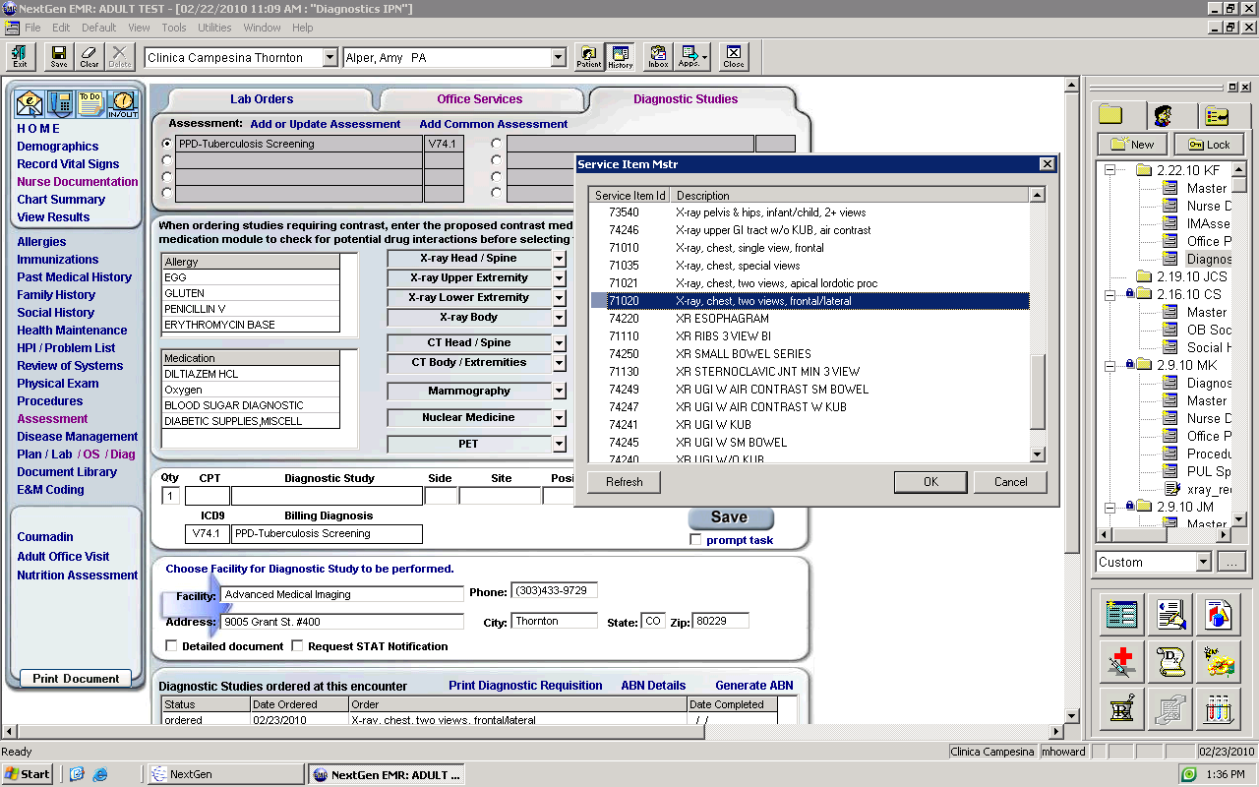

1. Click Diagnostics

**2**

1. Pick Assessment
2. Choose facility for xray
3. X-ray Body
4. Xray Chest, two views, frontal/lateral for patients < 12 yrs, all others frontal only.

**5**

**4**

1. Save
2. Print Diagnostic Requisition

**1**

**1**

1

**6**

**2**



**3**

**7**

**Billing**

* If pt is here for an INS physical, bill as usual.
* If pt is NOT here for an INS physical, send task to Billing and request that they bill visit as NO CHARGE.

**Chest X-ray Results, see** **below**

* Abnormal films. If the initial chest x-ray is abnormal and compatible with active or inactive TB, send the patient to the [Denver Metro TB Clinic](http://www.dhha.org/portal/Services/DenverPublicHealth/TuberculosisTBClinic/tabid/301/Default.aspx) for further evaluation. They can f/u with PCP after treatment there.
* Normal films.
  + If the initial chest x-ray is normal, the individual may receive their LTBI treatment through Clinica .
  + Repeat chest x-rays are not indicated unless the individual develops signs or symptoms of TB disease.
  + Anyone considering LTBI tx should have a current chest x-ray to rule out active pulmonary TB disease.
  + See treatment regimen below.
  + Please note, when screening for Homeless Shelter patients, a patient with a history of a positive ppd only needs a negative chest xray 2 years in a row. Once negative x 2 years, they would not need an additional cxr unless they should become symptomatic.

**Treatment**

* See guidelines for dispensing INH found below or on page 9 in the [Denver Health Latent TB Protocol](../../../Section%20IV_Reference/Denver%20Health%20TB%20Protocol.pdf).
* Latent TB Protocol INH
  + Dosing for adults 5mg/kg/day (max 300mg per day) x 9 months
  + Children 10-15mg/kg/day (max of 300mg per day) x 9 months
  + Round dose to the nearest 50mg
* Meds should be taken for 9 months, a 6 month regimen also offers substantial protection but 9m is preferred.
* INH should be given at bedtime with plenty of water due to possible stomach upset.
* Print and give attached INH medication information sheets in English or Spanish.
* Routine monitoring of liver function is not necessary unless patient is at risk for hepatic disease or HIV infected
* Vitamin B6 is used occasionally for adults
  + See also special considerations section on pages 9 & 10 of from the Latent TB Protocol (CHS LTBI Protocol File) of Denver Health found in the Resources File of Nursing Protocols.
* Recall via tasking for evaluation in 30 days.

**Education**

* Importance of taking daily medication for 9 months.
* Side effects, see below or page 22-23 of [Denver Health Latent TB Protocol](../../../Section%20IV_Reference/Denver%20Health%20TB%20Protocol.pdf).
* Drug interactions, see below or page 23 of [Denver Health Latent TB Protocol](../../../Section%20IV_Reference/Denver%20Health%20TB%20Protocol.pdf).
* Monthly evaluation by phone or appointment at provider discretion
* Handouts in English and Spanish explaining TB.

*Call back for appointment with provider if:*

* Patient reports symptoms of TB
* Liver function test are abnormal
* Patient develops symptoms of hepatitis (jaundice, abdominal pain, tea color urine, nausea or vomiting)

Document all of Above in Medical Record and have PCP Cosign

** TNF blockers target and neutralize tumor necrosis factor-alpha (TNF-α), a protein that, when overproduced in the body due to chronic inflammatory diseases, can cause inflammation and damage to bones, cartilage and tissue. The drugs in this class include Remicade (infliximab), Enbrel (etancercept), Humira (adalimumab), Cimzia (certolizumab pegol) and Simponi (golimumab). (FDA, 2009).

**From Denver Health Community Health Services Protocol for Latent TB Infection (LTBI) Diagnosis and Management Pediatric and Adult Patients, from page 9 and on.**

***D. Classifying the TST back to top***

|  |  |
| --- | --- |
| Whether a reaction to the TST is classified as positive depends on the size of the induration and the person's medical and epidemiologic risk factors for TB. Patients who have a positive TST reaction should receive a clinical evaluation, including a chest x-ray, to rule out active TB disease. **5 or more millimeters of induration** | **10 or more millimeters of induration** |
| 􀂃 Significant exposure to anyone with suspected or known TB  􀂃 Any individual being evaluated for disease consistent with tuberculosis  􀂃 Persons with x-ray evidence of old, healed TB (e.g., stable, fibrotic upper lobe infiltrates)  􀂃 Persons with behavioral risk factors for HIV infection who decline HIV testing, including persons of unknown HIV status who have a history of drug injection **‡**  􀂃 Immunosuppressive conditions or patients currently taking or planning to take certain medications: **‡**  􀂾 HIV-seropositive  􀂾 Congenital conditions causing immunosuppression  􀂾 Malignancies / cancers (e.g. cancer of the head and neck, lymphomas, leukemias)  􀂾 Individuals receiving the equivalent of > 15 mg/day of prednisone for at least one month. (Children receiving 0.5 mg/kg/day of prednisone)Individuals receiving inhaled steroids are not usually considered at increased risk unless unusually large doses are given  􀂾 Chemotherapy for cancer  􀂾 Tumor Necrosis Factor (TNF) blockers such as infliximab (Remicade), etanercept (Enbrel) for arthritis/Crohn’s disease  􀂾 Transplant patients (solid organ or bone marrow) on medications to prevent rejection  􀂾 Other medications such as methotrexate or cytoxan  􀂃 Those having an Immigration and Naturalization Service (INS) “change of status” exam | 􀂃 All children younger than 5 years old (i.e., up to the day of the fifth birthday)  􀂃 Persons who were born or lived in a country or area where TB incidence is high (e.g. Asia, Africa, Latin America, Eastern Europe, Russia or parts of Western Europe)  􀂃 Employees (including volunteers) or residents of congregate settings, such as hospitals, correctional facilities, homeless shelters, nursing homes, or drug treatment centers  􀂃 Employees or volunteers in health care facilities  􀂃 Persons with a history of drug injection or substance abuse (i.e., alcohol abuse or crack cocaine use) who are known to be HIV seronegative  􀂃 Persons with an increased risk of progression to TB disease (excluding HIV) such as: diabetes mellitus, silicosis, cancer of the head and neck, hematologic and reticuloendothelial disease (e.g., leukemia and Hodgkin's disease), end-stage renal disease, intestinal bypass or gastrectomy, chronic malabsorption syndromes, or low body weight (10% or more below ideal) ‡ |

**‡** Common causes of anergy, the patient may have a negative or a smaller TST test despite having TB infection.

■ Do NOT place a TST if the individual has recently (within 6 wks) had a live virus vaccination (e.g. MMR, Varicella). It can result in a false-negative TST.

■ Low risk patients do not need screening. If a TST is placed, interpret as positive if > 15 mm induration.

Back to top

**DH, CHS–LTBI, DIAGNOSIS AND MANAGEMENT-07/2006** 8

III. Clinical Evaluation for TB Infection and Active Disease

All individuals found to have a positive TST reaction should be screened by history for signs, symptoms and risk factors of active TB and should have a chest x-ray, to rule out pulmonary TB disease before initiating treatment for LTBI. The primary site of infection is the lung, but systemic dissemination of bacilli results in seeding of multiple organs. Hence, TB may present in variable combinations of pulmonary and extra pulmonary disease, especially in children. The likelihood of these presentations differs significantly depending on the age of the patient at the time, particularly the age at the time of primary infection.

NOTE: The presence of TB symptoms should always lead to a new clinical and/or chest x-ray evaluation.

***A. Chest X-Rays***

**1. Chest x-ray views**

**PA and Lateral**. Children 12 years of age or younger (i.e., up to the 13th birthday) should have both a PA and a lateral chest x-ray (age 12 years recommended by John Ogle M.D., 2002 ATS/CDC guidelines say age 5 years). The lateral view is important to help visualize adenopathy.

**PA only**. Children and adults over age 13 years only need a PA view, with additional views at the provider’s discretion.

**2. Scheduling and timing of chest x-rays**

Chest x-rays should be performed at the hospital. (If possible, for pediatric films, try to have them taken between 7am and 3pm Monday through Thursday. The quality of the film is usually much better, and the need to repeat the films is dramatically reduced if films are taken at these times. An under-penetrated or uninflated film is still easily interpretable where the question is bronchiolitis, but usually needs to be repeated if the question is TB.)

Indicate on the chest x-ray request that the patient has a positive TST. Inadvertent treatment of active TB with isoniazid alone can lead to acquired drug-resistance, so the timing of a chest x-ray before starting LTBI treatment is important.

Back to top

**3. Chest x-ray findings**

**Abnormal films**. If the initial chest x-ray is abnormal and compatible with active or inactive TB, send the patient to the Denver Metro TB Clinic for further evaluation.

Radiographically, active TB is characterized by various combinations of: hilar, mediastinal, and/or paratracheal lymphadenopathy; atelectasis, consolidation of lung parenchyma; mid- and lower lung zone infiltrates or scarring; nodules; calcifications and pleural effusion. Cavitary lesions and upper lobe infiltrates, which are typical in adult TB, are uncommon in children, but may be seen with malnutrition, immunodeficiency or in adolescents. A study of immigrants undergoing INS “change of status” exams in Denver found 42% were PPD-positive. Chest x-rays with any abnormality were found in 10% of TST-positive immigrants, and 1.7% of those evaluated for abnormal X-rays had active TB. Thus, active TB was found in 1.7 per 1,000 immigrants with a positive TST.

**Normal films**. If the initial chest x-ray is normal, the individual may receive their LTBI treatment through Community Health Services. Repeat chest x-rays are not indicated unless the individual develops signs or symptoms of TB disease. Anyone considering LTBI treatment should have a current chest x-ray to rule out active pulmonary TB disease.

**Back to top**

***C.*** ***Side Effects***

Some of the common symptoms patients may present with are:

􀂃 Fatigue, Malaise ■ Loss of appetite ■ Abdominal pain

􀂃 Nausea, vomiting ■ Jaundice ■ Persistent dark urine

􀂃 Abdominal tenderness ■ Peripheral neuropathies ■ Itching/rash

􀂃 Unexplained elevated temp > 3 days

**Hepatitis** is the most severe toxic effect of isoniazid. Underlying liver conditions and concurrent use of other potentially hepatotoxic drugs and alcohol pose the greatest risk.

The risk for INH-related hepatitis is minimal in infants, children, and adolescents, who generally tolerate the drug better than adults. Young children have less than 1% risk of hepatotoxicity. Routine monitoring of serum liver enzyme concentrations is not necessary in healthy children or adults but should be considered in individuals with known liver disease, patients on hepatotoxic drugs, HIV-infected or others with compromised immune systems. Patients/parents should be counseled at each visit to watch for the early symptoms of hepatotoxicity, anorexia and malaise. Later symptoms are abdominal pain, nausea, and vomiting. Jaundice is a very late finding. The INH should be held and LFTs checked if symptoms of hepatotoxicity occur. In most individuals, LFTs will be normal. The most common cause of minor gastrointestinal symptoms is gastritis that generally improves with continuation of therapy. Therapy is interrupted only in asymptomatic individuals with liver function abnormality 3-5 times the normal range or in symptomatic individuals with lesser degrees of hepatitis. When children taking anti-TB therapy develop hepatitis, a search for causes other than INH or other drugs should be undertaken and the therapy discontinued.

**Peripheral neuropathy**, caused by interference with metabolism of pyridoxine (vitamin B6), is associated with INH administration but is uncommon in children on a normal diet or in adults when INH is given at a dose of 5 mg/kg. In persons with diabetes, uremia, alcoholism, malnutrition, and HIV infection, neuropathy is more common and pyridoxine should be given with INH. Pregnant women and persons with seizure disorders should also take both pyridoxine and INH. Routine administration of pyridoxine (vitamin B6) is not necessary for children taking INH, but may be considered for:

􀂃 breastfeeding infants

􀂃 children and adolescents with diets likely to be deficient in pyridoxine (meat/milk deficient diet, malnourished)

􀂃 pregnant teens

􀂃 HIV-infected children

􀂃 children who experience paresthesias while taking INH

**Mild central nervous system effects** (sleepiness, insomnia, headaches) are common with INH and may necessitate adjustments in the timing of administration of the drug to enhance compliance. Taking medications a couple of hours after eating rather than first thing in the morning on a completely empty stomach can often eliminate nausea and GI disturbances. Bedtime is a good time to suggest taking INH.

Back to top

***D.*** ***Drug Interactions***

INH has been reported to inhibit the metabolism of the following drugs. Nurses prescribing LTBI treatment by protocol should discuss possible side effects and drug interactions with a provider if the patient is on any of the following medications as dosages of these drugs may need to be adjusted to prevent toxicity:

􀂃 anticonvulsants

􀂃 haldoperidol

􀂃 ketoconazole

􀂃 theophylline

􀂃 warfarin

􀂃 phenytoin- The interaction with isoniazid increases the serum concentration of both drugs, when given concomitantly, the serum level of phenytoin should be monitored

􀂃 disulfiram (Antabuse)- Some publications recommend against the use of isoniazid for persons taking disulfiram, but a recent article showed it can be used safely in patients being treated for active TB. It appears to be safer than alcohol abuse combined with isoniazid treatment.

􀂃 antiretroviral medications for HIV/AIDS- There are no known interactions that exist between INH and the antiretroviral medications used for the treatment of HIV infection.

􀂃 acetaminophen- It is important to caution patients/parents about excessive use of acetaminophen, and that ibuprofen is a better choice while taking isoniazid.

***E. Dispensing LTBI Medications***

The following medications should be dispensed in the same way as all other clinic medications. The patient should see the RN or provider monthly to receive refills/prescriptions. Only one month of medication should be given at a time with no refills.

Isoniazid (INH) - 300 mg scored tablets in bottles of #30

Isoniazid (INH) - 100 mg scored tablets in stock bottles of #100. These will need to be repackaged by the pharmacy into a quantity sufficient for 30 days.

Pyridoxine (Vitamin B6) - 25 mg bottles of #30. Not typically given to children, but used occasionally.

**Back to top**

Back to top

**INH Instructions on how to take INH** (2.6.2)

* Take 1 pill every day
* Try to take INH at the same time every day
* If you miss a day, do not take extra amounts of the medicine
* Try to take INHG two (2) hours before or after you eat
* Take Vitamin B6 100mg along with the INH if not a child.
* Avoid alcohol while taking INH
* Your dose is ________mg every day
* You will take INH for _______ months.
* Do LFT’s if symptomatic or history of liver problems.

# Possible side effects

* Rash
* Nausea/Vomiting
* Fever Feeling unusually tired
* Numbness or tingling in arms/legs
* Yellowing of skin/eyes
* Dark urine like coffee or tea

**INH instrucciones para como tomar INH** (2.6.3)

* Tome una pastilla diariamente
* Trate de tomarla a la misma hora todos los días
* Si se olvida un día, no tome 2 pastillas
* Trate de tomarla 2 horas antes o después de comer
* Tome la vitamina B6 junto con el INH
* No consuma bebidas alcohólicas mientras esta tomando INH
* El tratamiento es por _____________ meses
* Su dosis es de ________________mg al día
* Haga LFT’s si es sintomático o si tiene historia de problemas con el hígado

# Efectos secundarios posibles

* Sarpullido, Erupción de la piel, Picazón
* Nauseas o Vómito
* Fiebre
* Ictericia (piel amarilla o lo blanco del ojo amarillo)
* Adormeciendo u hormigueo en los brazos o piernas
* Orina oscura de color del café o té
* Sentirse más cansado de lo común

2.6.4

Back to topBack to top

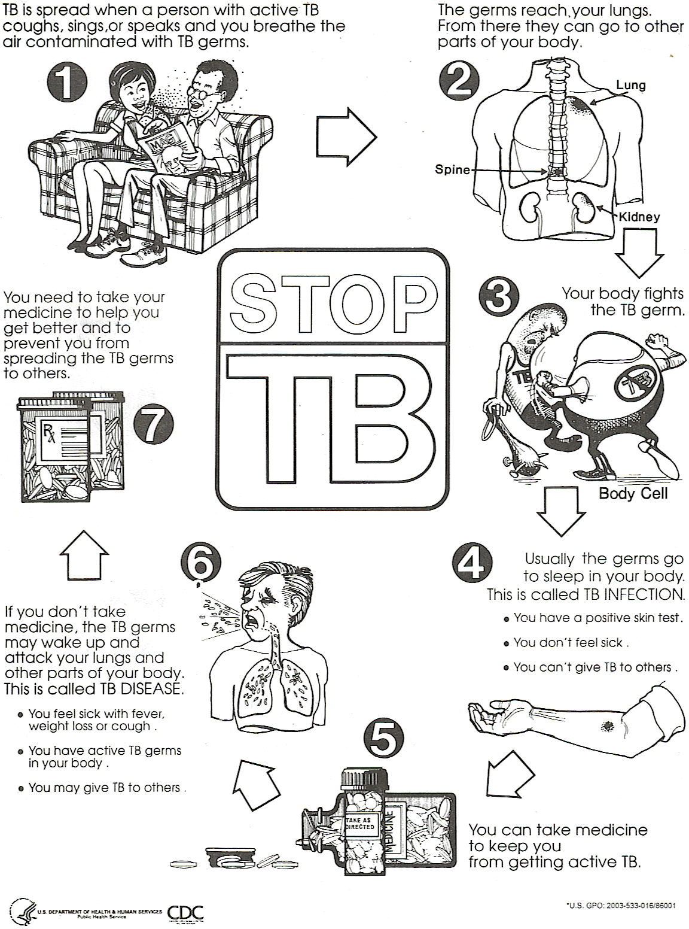

Back to top

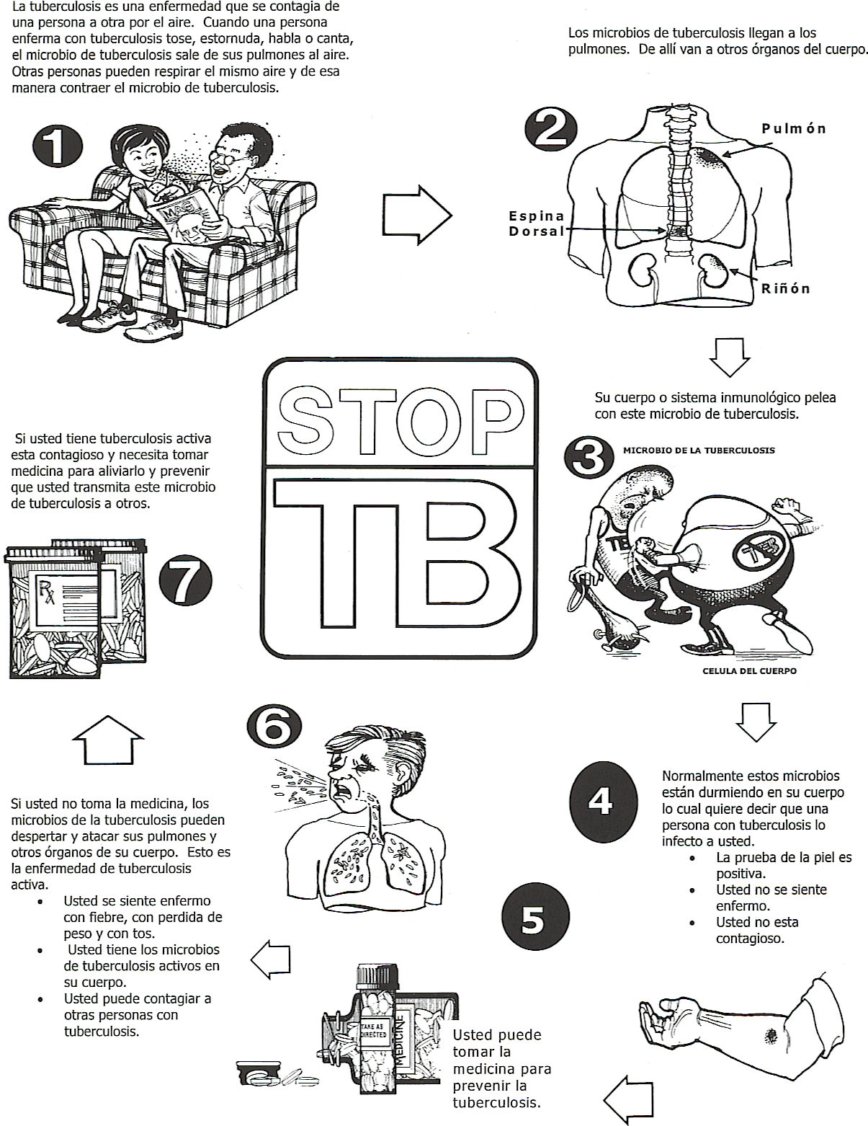

3.8 Glucola Contingency Plan

**Criteria: Brach’s Jelly Beans may be used instead of Glucola in the following situations.**

* **Patient with an allergy to an ingredient in Glucola. Must be documented in chart.**
* **Patient with a *documented failed attempt at the 1hr GTT with 50g of Glucola first*.**
* **Patient with a *documented failed attempt at the 3hr GTT with 100g of Glucola first*.**
* ***Patients who use Jelly Beans for the 1hr GTT must still attempt the 3hr GTT with 100g of Glucola first.***

Procedure:

* Brach’s standard sized Jelly Beans are the preferred brand.
* Check nutrition data to ensure the correct number of jelly beans are given for accurate 50g or 100g dosing.
  + Mathematical formula is as follows, **“pieces” = individual jelly beans**:
    - ___g Sugars **÷**  ServingSize of ____pieces = ______g of Sugars/piece
    - **50g** sugar (for 1-hr GTT) **÷**  ___g of Sugars/piece = ____jelly beans needed for 1-hr GTT
    - **100g** sugar (for 3-hr GTT) **÷** ___g of Sugars/piece = ____jelly beans needed for 3-hr GTT
    - **Always round up.**
  + For example, using the nutrition facts below--if 14 pieces (jelly beans) equals 27g of Sugars:
    - _27g_ Sugars **÷** _14_ pieces = **1.928g** Sugars/piece
    - **50g** sugar (for 1-hr GTT) **÷** **1.928g** Sugars/piece = 25.93 pieces → **26 jelly beans for 1hr GTT**
    - **100g** sugar (for 3-hr GTT) **÷** **1.928g** Sugars/piece = 51.867 pieces → **52 jelly beans for 3hr GTT**
* Jelly beans must be consumed within **10 minutes**.
* Continue testing as per regular procedure.
* Label bag with date opened and # of jelly beans required for 50g dosing.

|  |  |
| --- | --- |
| **Example Label**  **(not official or consistent,**  **always double check bag!)**  Nutrition Facts  Brach’s Jelly Beans Serving Size: 14 pieces (41.0 g) | |
| **Amount per Serving** | |
|  | |
| |  |  | | --- | --- | | Calories 150 | Calories from Fat 0 | | |
|  | |
| **% Daily Value \*** | |
| Total Fat 0g | **0%** |
| Saturated Fat  0g | **0%** |
| Monounsaturated Fat  0g |  |
| Polyunsaturated Fat  0g |  |
| Trans Fat  0g |  |
| Cholesterol 0mg | **0%** |
| Sodium 5mg | **0%** |
| **Potassium 0mg** | **0%** |
| Total Carbohydrate 37g | **12%** |
| Dietary Fiber  0g | **0%** |
| Sugars  27g |  |
| Protein 0g | **0%** |
|  | |



3.9 Antipyretics/Pain Reliever (Nurse Protocol)

**To provide nurses a protocol to order and dispense acetaminophen and/or ibuprofen to Clinica patients.**

***MAs: please see MA Standing Order for Antipyretics and Pain Relievers.***

**Subjective/Objective**

* Assess for fever. (Fever is ≥ 100.4F**)**
* No respiratory or other acute distress (respirations and pulse may be somewhat elevated due to illness, however)
* Other vital signs within normal limits.
* Pregnancy status, medical conditions, usage of other medications.
* Document drug allergies.
* Note last dosage of acetaminophen and/or ibuprofen and time last given.
* Additional subjective data to be determined by other presenting symptoms.

**Assessment**

* Fever, unspecified 780.60

**Treatment**

* **Infants and Children**
  + See **Tylenol/Motrin** dose schedule for Infants & Children [here](../../../Section%20IV_Reference/Tylenol_Motrin%20Dosing%20Schedule.pdf) or below. Do **not** exceed 5 doses/24hrs.
* **Adults**
  + **Acetaminophen:**  325-1000 mg PO Q4-6 hours according to dosing schedule. Max 1g/dose. Do **not** exceed 4g/24hrs.
  + **Ibuprofen:**
    - 200-400 mg/dose PO Q4-6 hours, max 1200mg/day for fever.
    - 400mg/dose PO Q4-6 hours, max 2400mg/day for mild to moderate pain.
* Order in Office Services, Misc. Drugs.

**Plan**

* Take with food.
* Continue as needed, taking medication on time as per dosing schedule or packaging provided with medication. Use lowest effective dose, for shortest treatment duration.
* Push fluids.

**References**

Uptodate. (2009). Retrieved 1/25/10 from <http://www.uptodate.com/online/content/topic.do?topicKey=drug_a_k/128401&selectedTitle=1%7E150&source=search_result#F181461>

McNeil. (2009). Motrin and Tylenol Professional Dosing Schedule for Infants and Children.

Epocrates. (2010). As retrieved 3/8/10.

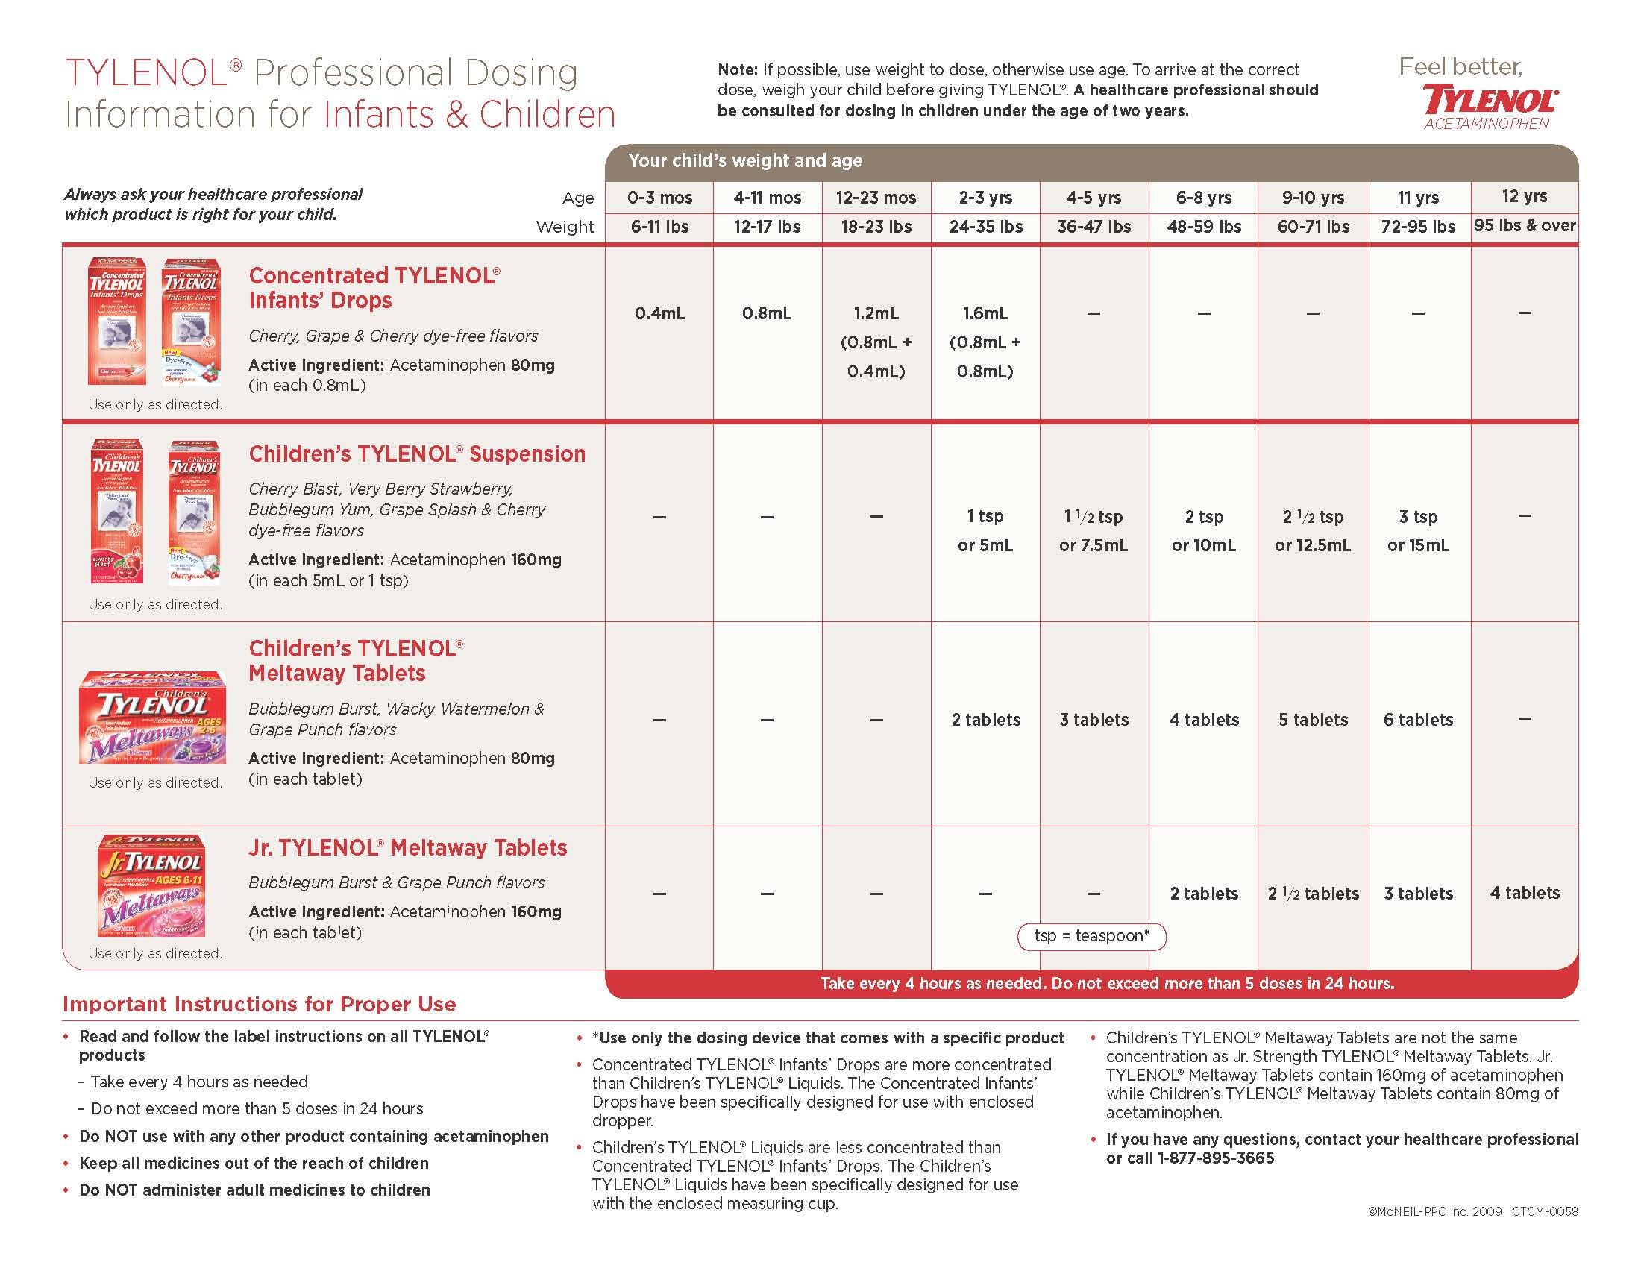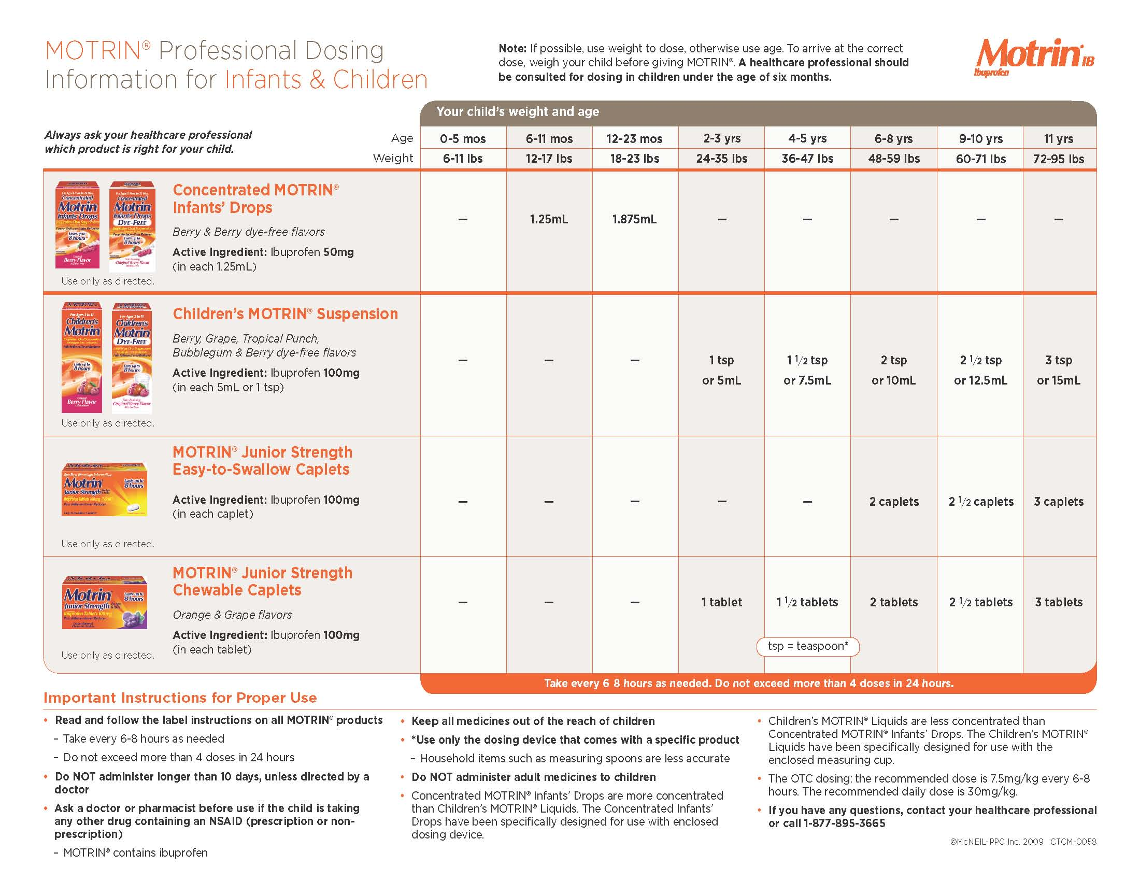

3.10 Non-Stress Test

**To provide nurses guidelines for how to perform a non-stress test (NST) for fetal assessment. This protocol is adapted from Avista Adventist Hospital New Life Center GUIDELINE NO. 3104 REVISION J, 6/08.**

**Subjective/Objective**

* Note reason and frequency for NST monitoring.
* OB vitals: urine analysis, weight, BP, abdominal measurement, s/s bleeding, preterm labor, DTR, maternal assessment of fetal movement.

**Procedure**

* Obtain a fetal monitor strip for a **minimum of 20 minutes**
  + A **reactive NST** for a **fetus ≥ 32 weeks gestation** consists of
    - 2 FHR accelerations occurring within a 20 minute timeframe, with or without perception of fetal movement by the woman. If little reactivity in first 20 minutes, juice or fetal stimulation may be attempted.
      * Apex (or peak) of acceleration is ≥15 bpm above the baseline;
      * Acceleration lasts ≥ 15 seconds to < 2 minutes, (from onset to return to baseline) and peaks within < 30 seconds.
      * Fetal heart rate between 120-160.
  + A **reactive NST** for a preterm **fetus between 24-32 weeks gestation** consists of
    - 2 FHR accelerations occurring within a 20 minute timeframe, with or without perception of fetal movement by the woman. If little reactivity in first 20 minutes, juice or fetal stimulation may be attempted.
      * Apex (or peak) of acceleration is ≥10 bpm above the baseline;
      * Acceleration lasts ≥ 10 seconds, (from onset to return to baseline).
      * Fetal heart rate between 120-160.
  + A **non-reactive NST** is a 40-minute strip that does not meet defined reactive criteria based on gestation.
  + An **unsatisfactory NST** is a tracing of poor quality that cannot be interpreted because the tracing is not continuous, artifact is present, or gaps appear.
  + If monitoring **twins**, specify in EMR which twin is baby A and which twin is baby B.
    - Document this in relation to mom’s abdomen. Ex: Baby A = lower maternal right, Baby B = upper or mid maternal left.
    - When monitoring twins, both babies do not need to be reactive within the same 20 minutes, but both babies must be tracing concurrently in order to determine that there are two FHRs when determining reactivity. This means strip may need to be >20 minutes long in order to demonstrate 2 independent FHRs were recorded and that both babies were individually reactive for the specified amount of time indicated in the guidelines according to gestational age.
* **Give provider the results of NST using the descriptors “reactive,” “non-reactive,” or “unsatisfactory.”**
* **A provider must review all NSTs before the patient is allowed to go home.**

**Assessment**

* Post term pregnancy 645.13
* Prenatal care, high risk, unspecified V23.9
* Pregnancy twin 651.03

**Plan**

* Schedule appointment for next NST or provider appointment.
* Review labor/ER precautions
* Place signed strip in Med Records in-box to be scanned into the EMR.

**References**

Avista Adventist Hospital New Life Center. (2008). GUIDELINE NO. 3104 REVISION J, 6/08.

**Baird, S.M. & Ruth, D.J. (2002). Electronic fetal monitoring of the preterm fetus.** Journal of Perinatal and Neonatal Nursing, 16, 12-24.

**Electronic fetal heart rate monitoring: Research guideline for interpretation.** American Journal of Obstetrics and Gynecology 177 (6), 1385-1390.

Lyndon, Audrey & Usher, Linda. Fetal Heart Monitoring Principles and Practices, Fourth Edition. AWHONN, 2009.

3.12 PHARYNGITIS PROTOCOL, INCLUDING RAPID STREP TESTING

SUBJECTIVE

* Complaint of sore throat, with or without dysphagia/odynophagia
* Abdominal pain and/or vomiting
* Headache
* Fever
* Absence of cough (generally, but not always)
* Possible chills or body aches

OBJECTIVE

* The McIsaac modification of the **Centor Scoring Tool** is used to determine the likelihood of group A streptococcal infection in people presenting with pharyngitis. Based upon 5 clinical criteria, it indicates the probability of a streptococcal infection before any testing is done (“pretest probability”):

|  |  |
| --- | --- |
| **Criteria for Modified Centor Scoring Tool** | **Points Awarded** |
| History of temperature > 38º F or > 100.4 º F | 1 |
| Absence of cough | 1 |
| Swollen, Tender Anterior Cervical Nodes | 1 |
| Tonsillar Swelling or Exudate | 1 |
| Age  3-14 years  15-44 years  ≥ 45 years | 1  0  -1 |

**Modified Centor Score, Strep Probability, and Management**

|  |  |  |
| --- | --- | --- |
| **Centor Score** | **Probability of Strep** | **Management** |
| 0 | 1-2.5 % | No antibiotic or testing needed |
| 1 | 5-10 % |
| 2 | 11-17% | Rx antibiotic based upon rapid strep result |
| 3 | 28-35% |
| 4 or 5 | 52% | Rx antibiotic based upon rapid strep result * |

*\*May treat without rapid strep test after consulting with provider.*

* Run Rapid Strep: CPT code 87880 and document results in Nursing Documentation.
* If Centor scale >2, document numerical score in Comments section when reporting rapid strep results.
* If <1, document score in Comments section of physical exam.
* If rapid strep test is positive, treat with antibiotic as noted below.
* If rapid strep test is negative, send throat culture if patient is < 18 years of age. If 18 or older, no throat culture is needed.
* To order Group A Strep Culture through Quest use order code 112680E.

TREATMENT

* **Children ≤ 27 kg (60 lbs)**
  + penicillin V 250 mg PO BID ×10 days **or**
  + Amoxicillin 50mg/kg once daily x 10 days (for children >3 months and < 40kg). [Max dose of 1000mg. ]
    - If over 5 years old use 250mg TID in either chewable or liquid forms **or**
  + penicillin G benzathine (Bicillin® L-A) 0.6 million units IM (useful if provider in office and patient has difficult swallowing or you are worried about poor adherence to the treatment plan; observe for 30 minutes after injection for possible anaphylaxis)
* **Children >27 kg and Adults**
  + penicillin V 500 mg PO BID ×10 days **or**
  + amoxicillin 1000 mg once daily for 10 days **or**
  + penicillin G benzathine (Bicillin® L-A) 1.2 million units IM (useful if provider in office and patient has difficult swallowing or you are worried about poor adherence to the treatment plan; observe for 30 minutes after injection for possible anaphylaxis)
* **If allergic to penicillin:**
  + **Children <27kg**: erythromycin ethylsuccinate (EES, EryPed®) PO 40mg/kg/day divided BID ×10d
  + **Adults & adolescents >27kg:** erythromycin base (Ery-Tab®—250 mg, 333 mg or 500 mg—or PCE®—333 mg or 500 mg) or stearate (Erythrocin®—250 mg or 500 mg) PO, 1 gm/day, divided into 2-4 doses

**OR**

* **Children < 27kg**: azithromycin 12mg/kg PO once daily for five days.
* **Adults and adolescents >27kg**: azithromycin 500mg tablet PO on day one followed by 250mg tablet daily on days two through five.
* **Can also use guideline below, from UpToDate For some patients with insurance, azithromycin course can result in greater** adherence to the treatment plan**.**

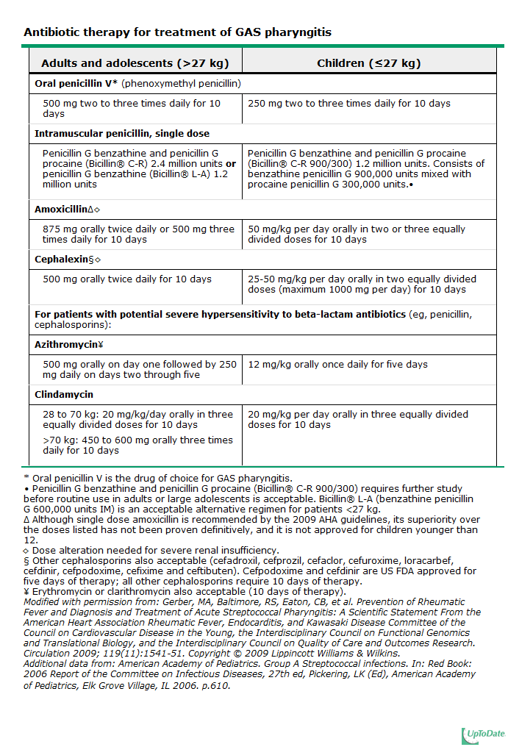

PATIENT EDUCATION

* If antibiotic prescribed, complete the full 10-day course, even if symptoms have improved.
* No school or work until on antibiotics for at least 24 hours.
* Push fluids (tea, water, sports drinks, juice). Adults should be encouraged to take 2-3L per day especially when febrile.
* Pain/fever reliever (e.g., ibuprofen or acetominophen, dosed for age)
* Gargle with saline. To prepare saline at home use 1 tsp of non-iodized salt mixed with 1 cup water.
* Lozenges
* Rest
* Discard, wash in dishwasher, or boil toothbrush after 48 hours of antibiotic treatment
* If any family members/contacts of patient with confirmed strep throat develop sore throat (with or without fever) within 2 weeks, encourage they call as you may treat them presumptively
* Notify provider if not improving after 2 full days of antibiotics

***Call back for appointment with provider if:***

* Temperature >104° F or does not improve after 24 hours of medication.
* Signs (rash, swelling) or symptoms (difficulty breathing) of allergy to antibiotics

**Document all of Above in Medical Record SEND COPY OF MASTER IM TO PCP FOR NOTIFICATION**

**Other Resources and References:**

* **Sec XII-Rapid Strep Test 1.doc** [**P:\Clinical\Lab Manual\Sec XII-Rapid Strep Test 2.6.12.doc**](../../../Lab%20Manual/Sec%20XII-Rapid%20Strep%20Test%202.6.12.doc)
* **Empirical Validation of Guidelines for the Management of Pharyngitis in Children and Adults:** [**http://jama.ama-assn.org/content/291/13/1587/F1.expansion**](http://jama.ama-assn.org/content/291/13/1587/F1.expansion) **(also on Clinica P:\ drive)**
* **AFP Summary Article 2009:** [**http://www.aafp.org/afp/2009/0301/p383.html**](http://www.aafp.org/afp/2009/0301/p383.html) **(also on Clinica P:\ drive)**
* **UpToDate (log-in required):**

[**http://www.uptodate.com/contents/approach-to-diagnosis-of-acute-infectious-pharyngitis-in-children-and-adolescents?source=search_result&search=strep+pharangitis&selectedTitle=2%7E150#H18**](http://www.uptodate.com/contents/approach-to-diagnosis-of-acute-infectious-pharyngitis-in-children-and-adolescents?source=search_result&search=strep+pharangitis&selectedTitle=2%7E150#H18)

* **More articles can be found on Clinica P:\ drive:** **\\dbserver\Public\Clinical\Clinical Reference\ENT\Pharyngitis**
* **MD Calc with scoring tool for Modified Centor Score; also pasted below:** [**http://www.mdcalc.com/modified-centor-score-for-strep-pharyngitis/**](http://www.mdcalc.com/modified-centor-score-for-strep-pharyngitis/)

Pertussis Prophylaxis Treatment Protocol

**This protocol should be performed via telephone to avoid exposing other clinic patients to possible infection. Instruct patient to make appointment if they have any “alarm symptoms”:**

* **apneas in an infant**
* **significant dyspnea or difficulty breathing**
* **“looks really sick”**
* **High fever, persistent vomiting, dehydration especially in infants.**

**Assessment**

* Review and document any medication allergies.
* Verify exposure to confirmed pertussis in close contact or in persons at high risk:
  + Close contacts are defined by:
    - Face-to-face exposure within three feet of a symptomatic patient
    - Direct contact with respiratory, oral, or nasal secretions from a symptomatic patient
    - Sharing the same confined space in close proximity with a symptomatic patient for ≥1 hour
  + Persons at high risk for severe or complicated pertussis include:
    - Infants younger than one year, particularly those younger than four months
    - Persons with immunodeficiency
    - Persons with underlying medical conditions (chronic lung disease, respiratory insufficiency, cystic fibrosis)
    - Because of the risk of severe disease in infants younger than one year of age, especially those younger than four months of age, women in the third trimester of pregnancy should be given post exposure prophylaxis

**Treatment**

* Initiation of post exposure prophylaxis in asymptomatic contacts within 21 days of the onset of cough in the index case can prevent the development of symptoms. The utility of post exposure prophylaxis after 21 days of onset of cough in the index case is unclear. We suggest antimicrobial prophylaxis for close contacts of the index case (regardless of immunization status) and for exposed individuals at high risk for severe or complicated pertussis.
* Chemoprophylaxis for pertussis consists of full dosing of antimicrobial therapy (see table below). Antimicrobial prophylaxis for contacts is probably most effective when initiated within 21 days of the onset of cough in the index patient

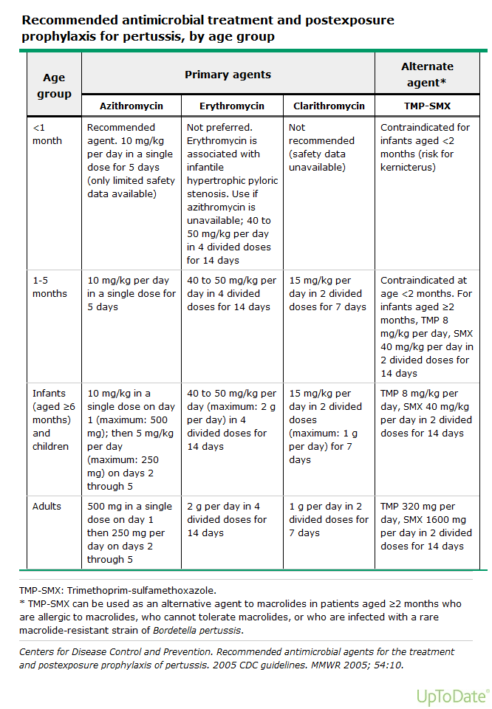

**Patient Education**

* Continue medication even after symptoms have improved for a full course of antibiotics as prescribed.
* Patients with B. pertussis infection should avoid contact with young children and infants, particularly unimmunized children, until they have completed at least five days of appropriate antibiotic therapy. Similarly, infected individuals working in schools, daycare centers, or healthcare facilities should not return to work until completing at least five days of appropriate antibiotic therapy
* If any family members/contacts meet conditions above (for close contract &/or high risk), treat presumptively
* Notify provider if not improving with antibiotics.
* Get plenty of rest
* Drink plenty of fluids
* Eat small meals to avoid vomiting after coughing
* Avoid being around people who are smoking
* If not up to date, recommend booster vaccination with Tdap for adolescents and adults, regardless of interval since last Td

*Precautions:*

* If your child has whooping cough, call for an ambulance (in the US and Canada, dial 9-1-1) if he or she:
  + - Stops breathing or has a hard time breathing
    - Has a seizure
    - Let the emergency workers know that your child has whooping cough so they can avoid getting or spreading the infection.
* Call the doctor or nurse if you or your child has whooping cough and:
* Gets a high fever
* Vomits over and over again
* Gets dehydrated – Dehydration is when the body loses too much water. It can make people feel thirsty, tired, dizzy, or confused, and have dark yellow urine.

**Document all of Above in Medical Record**

**and send “FYI” task to PCP.**

**General Information/Interesting Facts**

**Patient information: Whooping cough (The Basics)**

[Written by the doctors and editors at UpToDate](http://www.uptodate.com/contents/authors-and-editors/patient-information)

What is whooping cough? — Whooping cough is an infection that causes a severe cough. It can spread easily from person to person. The medical term for whooping cough is “pertussis.”

Most people get vaccines in childhood to prevent whooping cough. (Vaccines are treatments that can prevent certain serious or deadly infections.) Doctors recommend that babies and young children get 5 doses of the vaccine. They also recommend that children ages 11 to 12 and adults get 1 dose of the vaccine. It’s especially important that adults who are around newborn babies get the vaccine.

But children and adults can still get whooping cough. Babies can get the infection before they get all of their vaccine doses. Teens and adults can get it if they don’t get their vaccines, or if it has been a few years since their last dose of the vaccine.

What are the symptoms of whooping cough? — Early on, whooping cough usually causes sneezing, runny nose, stuffy nose, and other cold symptoms. It also causes a mild cough.

After 1 to 2 weeks, the cold symptoms get better, but the cough gets worse. People have severe coughing attacks. During these attacks, children can gag, choke, or have trouble breathing. People can also vomit from coughing so hard.

After 2 to 6 weeks, the cough starts to get better. But it can take weeks to months for the cough to go away completely.

Whooping cough gets its name because many people make a “whoop” sound when they breathe in after a coughing attack. But not everyone with whooping cough makes this noise.

How is whooping cough treated? — Doctors usually treat whooping cough with antibiotic medicines. The medicines can help the infection get better faster and keep it from spreading to others. Doctors can use different antibiotics to treat whooping cough, depending on the person’s age.

People living with the infected person might also need to take antibiotics, even if they aren’t sick. This can help keep them from getting the infection.

Most babies need to be treated in the hospital. That’s because the infection is very serious and can be deadly in babies. In the hospital, doctors can watch a baby closely and give him or her oxygen, fluids, and nutrition (if necessary).

How can I prevent spreading whooping cough? — You can:

●Cover your mouth when you cough, or wear a mask.

●Wash your hands often.

●Avoid being near babies and young children until you have been on antibiotics for 5 days. If you work with young children or babies, do not return to work until you have been on antibiotics for 5 days.

●Make sure the other people in your home get the pertussis vaccine if they haven’t had it. If your child has whooping cough, make sure the people who live with and take care of him or her get the pertussis vaccine if they haven’t had it.

●Not let your child return to school or day care until the doctor or nurse says it’s OK.